Add RegisterBlast to Brightspace Course

- Login to Brightspace
- Click desired Course Tile under My Courses
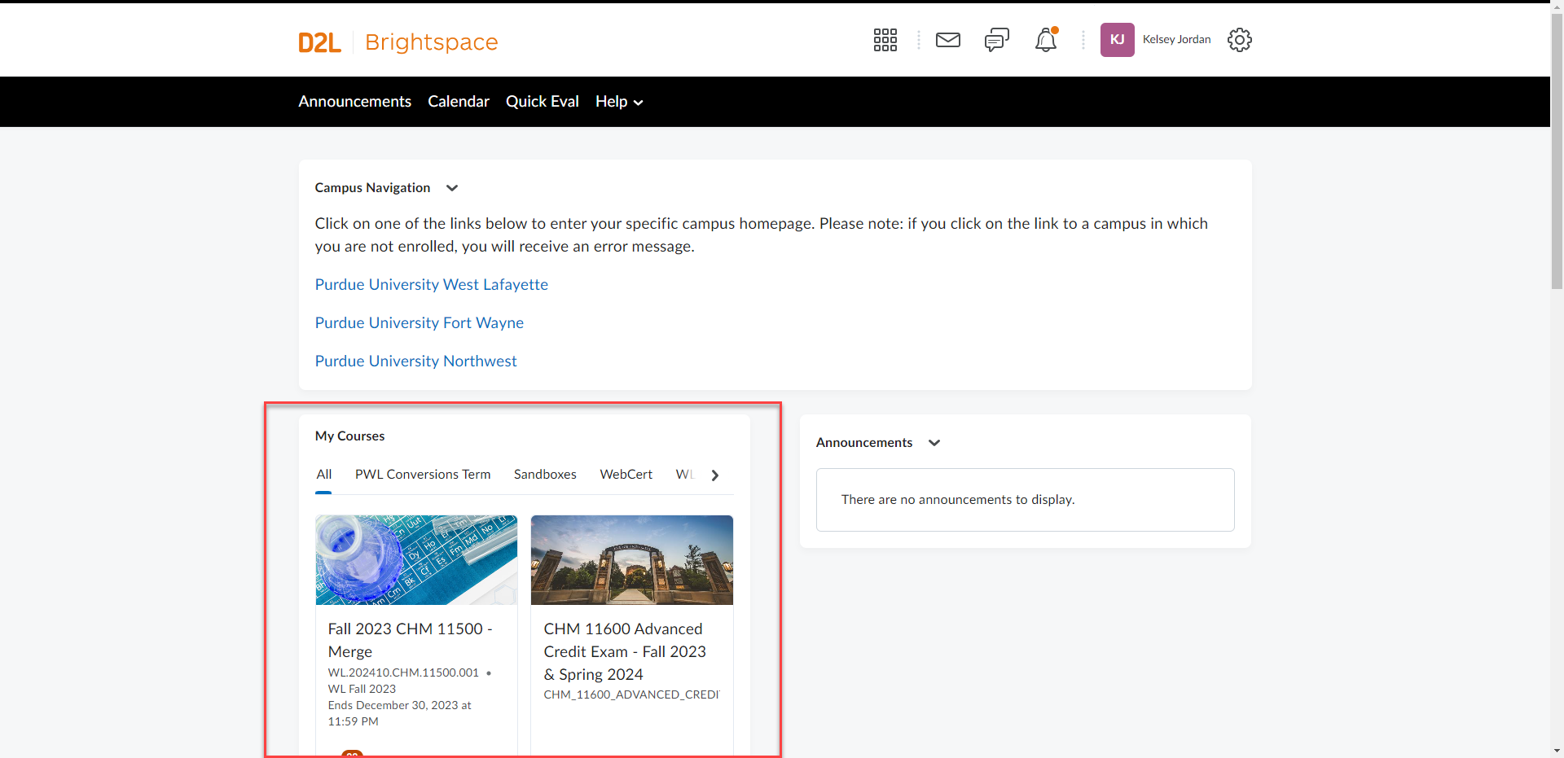

- Click “Content:”
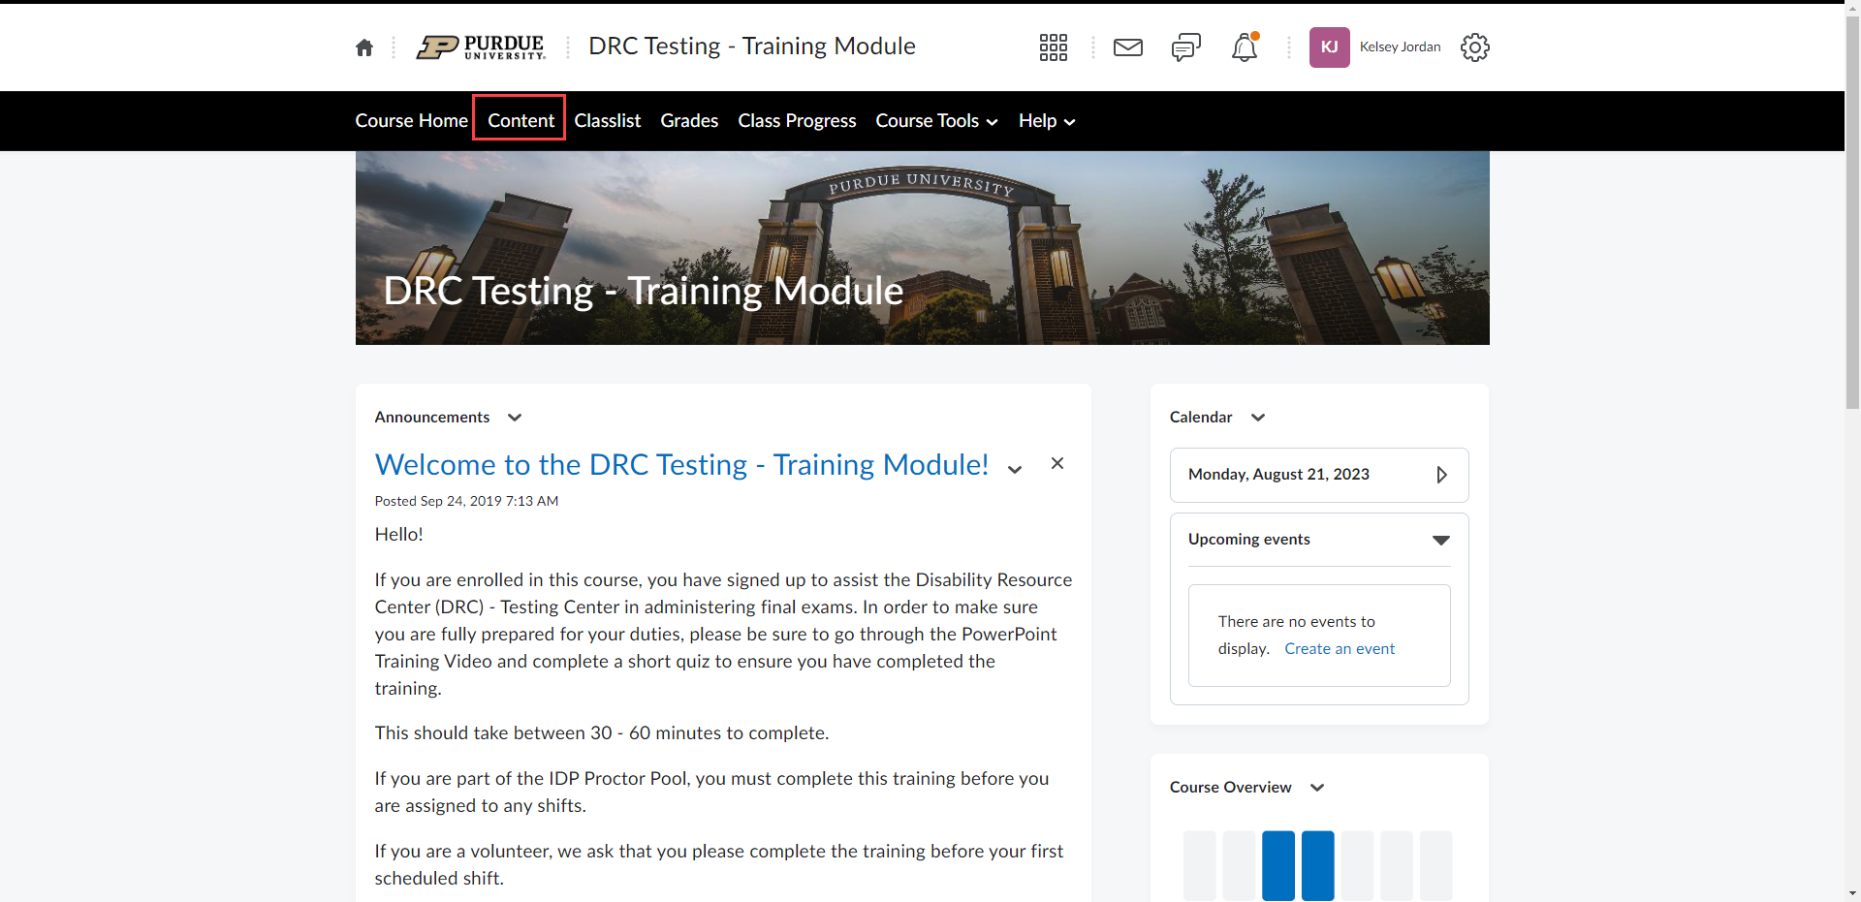

- Click “Add a Module” and name it “Accommodated Testing”
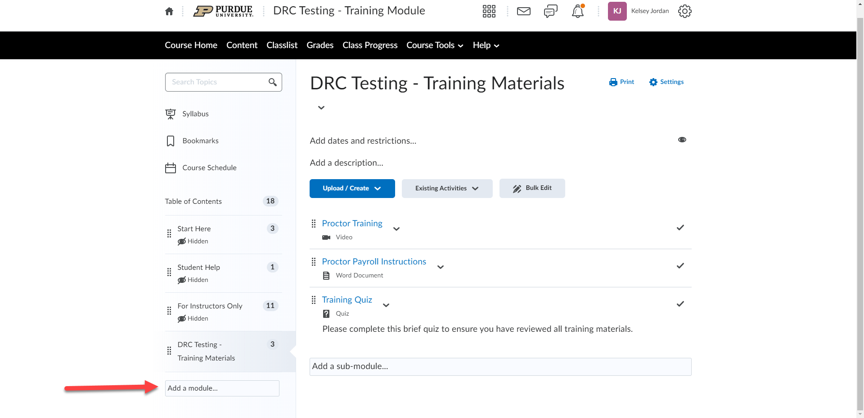

- Click “Existing Activities”
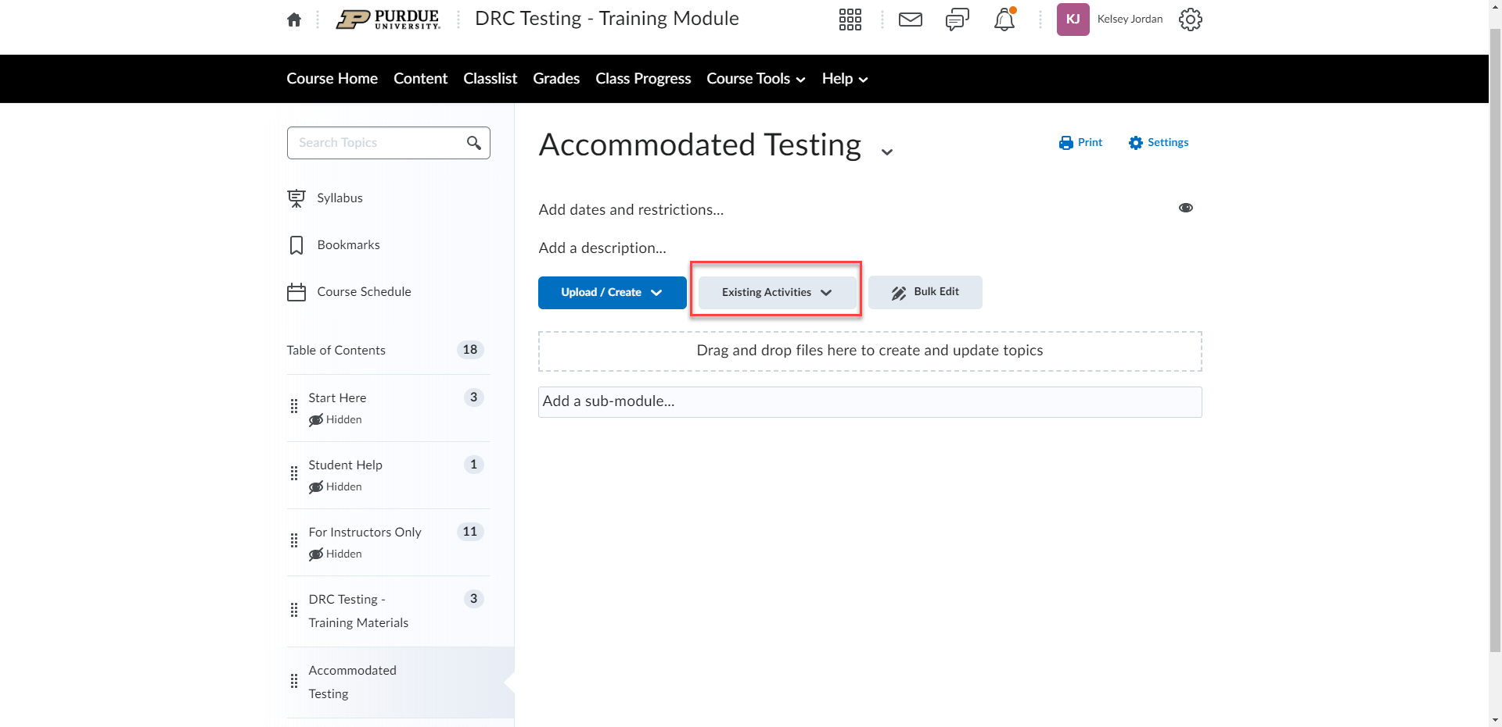

- Click “External Learning Tools”
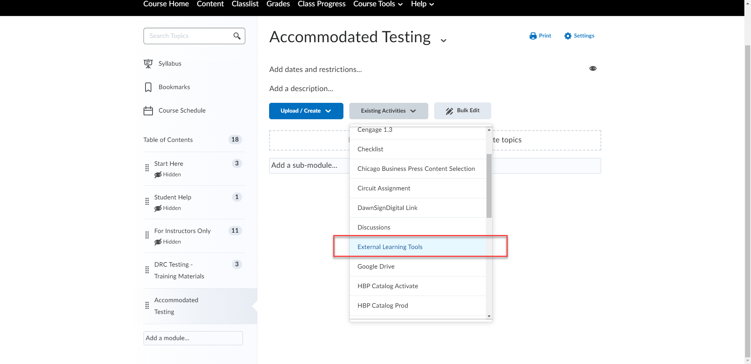

- Type “RegisterBlast” into the search box and click the search icon
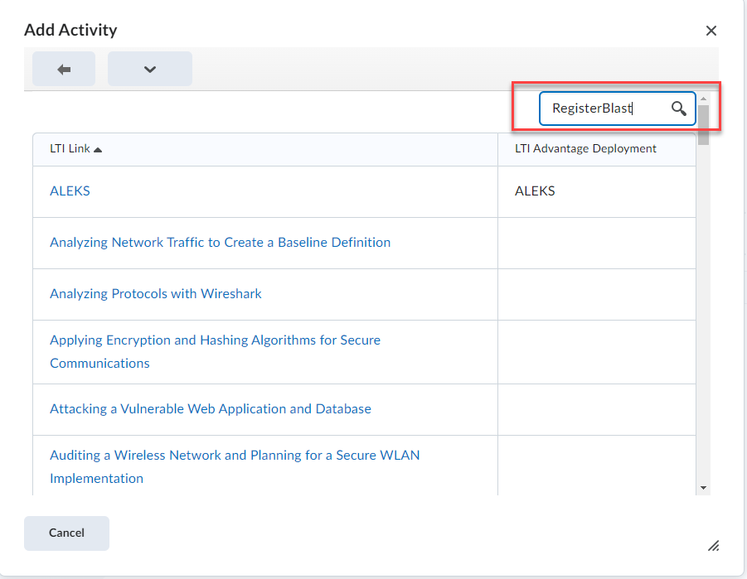

- Click on the LTI Link “RegisterBlast – West Lafayette”
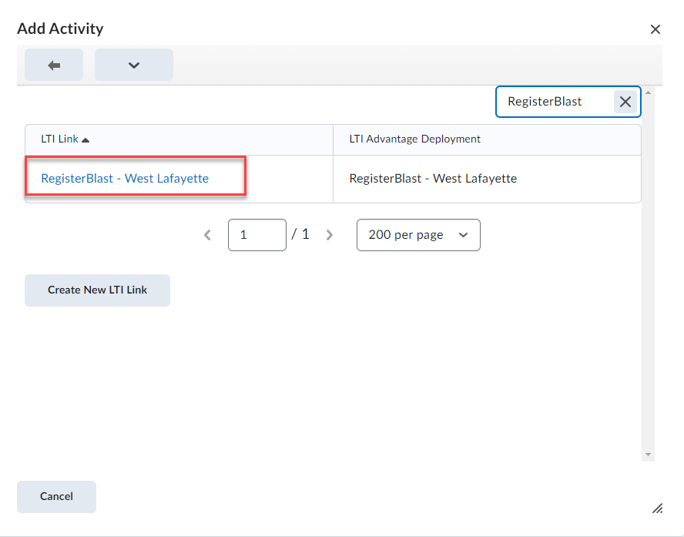

- The link to RegisterBlast is now available in your course
