How to Submit a TIF in RegisterBlast

- Click on “RegisterBlast – West Lafayette” LMS link in Brightspace (see Add RegisterBlast to Brightspace Course guide if you have not done this step yet).
Screenshot of Brightspace home page. Red box over My Courses section.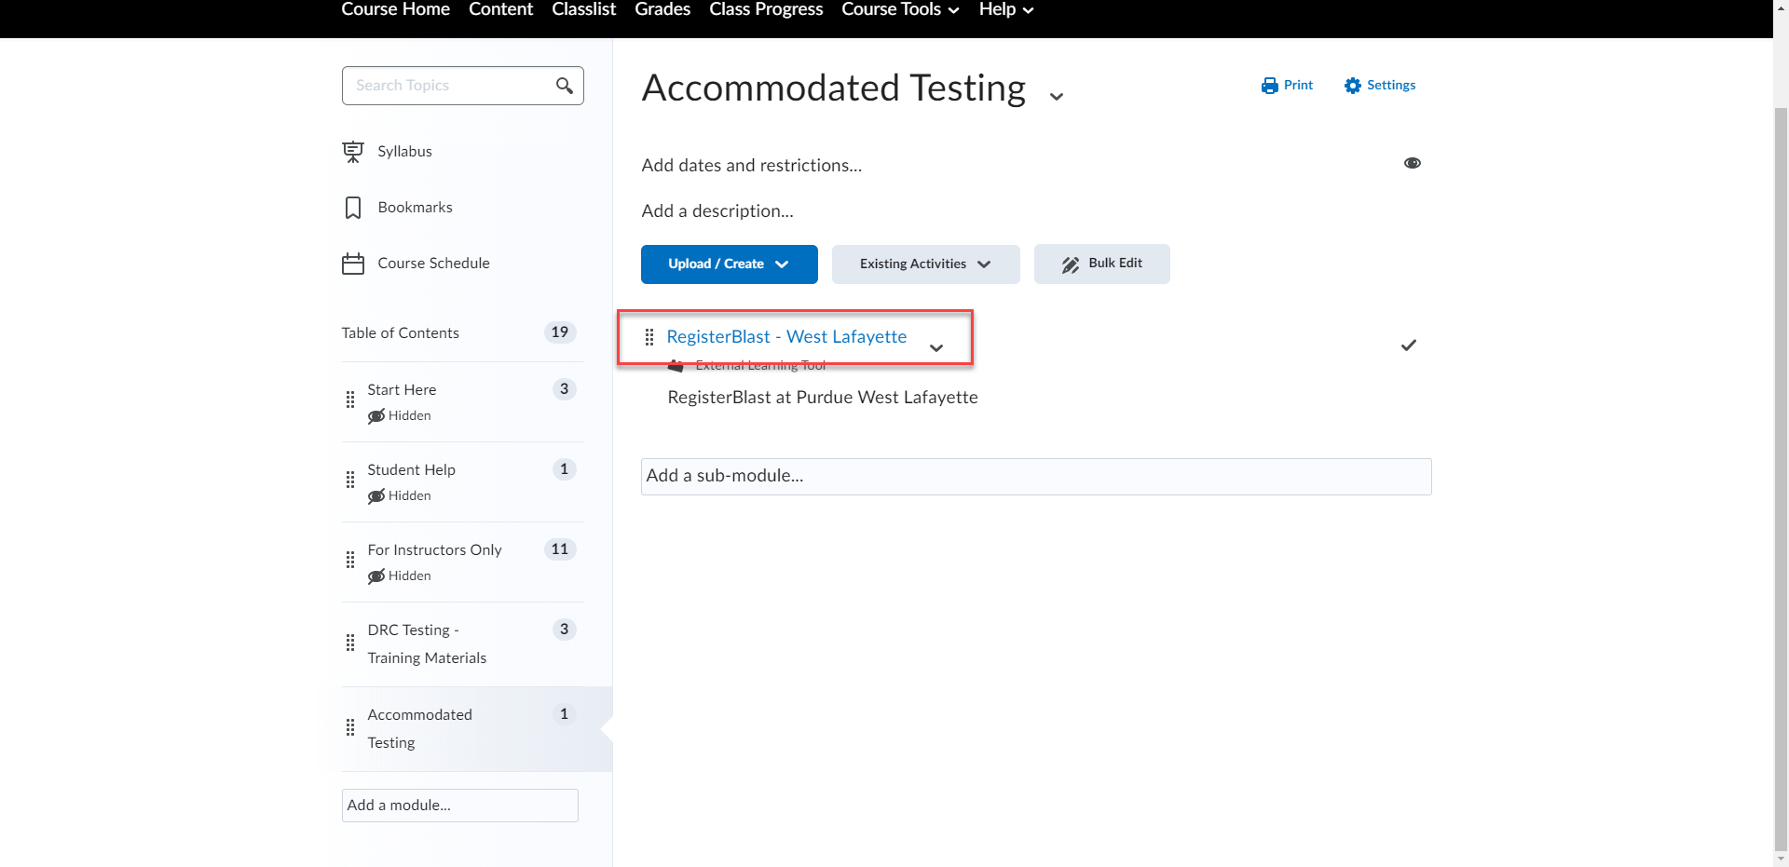

- Click the “+” button to add a new Testing Instruction Form (TIF)
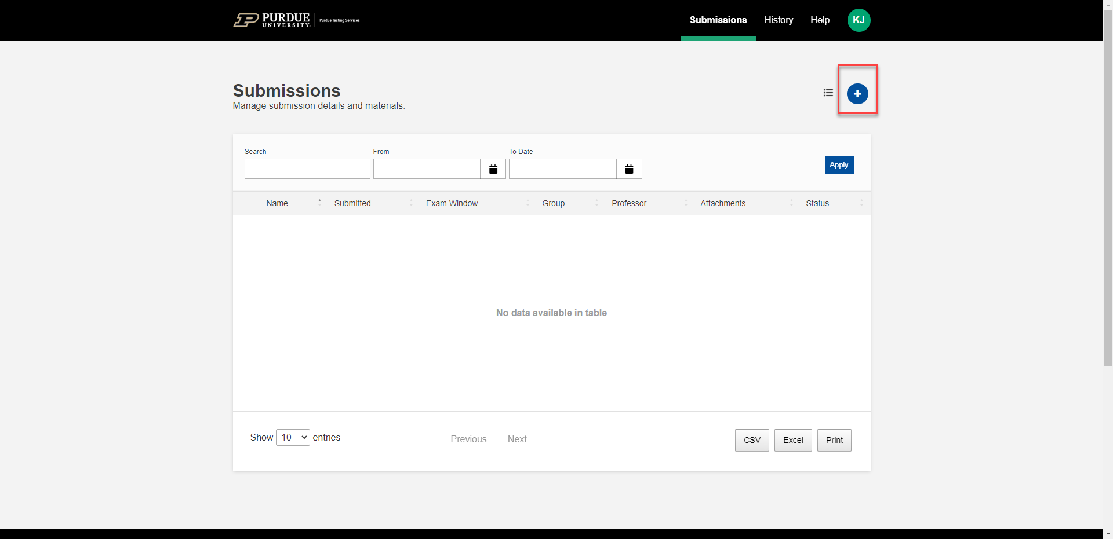

- Fill out the TIF details
  - Exam Title (ex. MA 161 – Exam 1 or CHM 125 – Final)
  - Select the exam group/s for this test – This should auto populate the courses you are associated with in Brightspace
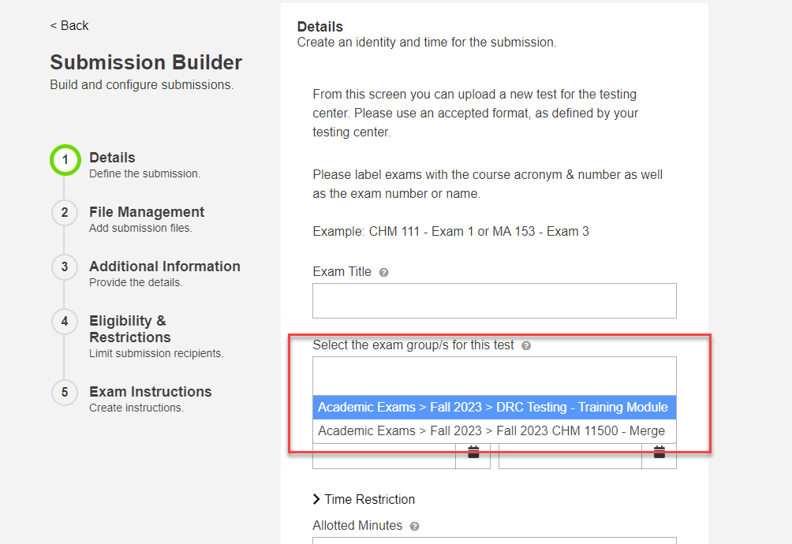

  - Start Date and End Date – These are the dates in which the student can schedule their exams. If they can only schedule on one specific date, make sure to do the same date for both the start and end.
  - Time Restriction - This is the time window in which students can schedule their exams. If they can schedule for any time on the specified date(s), you do not need to complete this step.
  - Allotted Minutes – Length of time for the classroom exam (Do not include accommodated time)
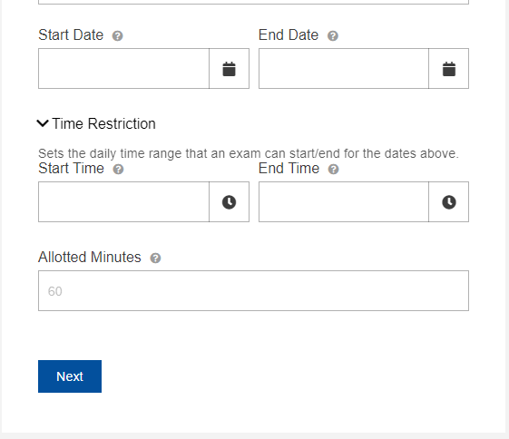

- File Management – If you have a copy of the exam ready at the time of submitting the TIF, you can upload it using this section. If you do not have a copy ready, please skip this section.
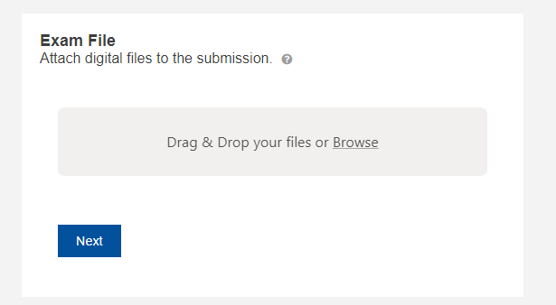

- Testing Instructions
  - How will you provide the exam to PTS for administration?
  - Is a calculator allowed?
  - Does this exam require a Scantron?
  - Are crib sheets/notes/textbooks allowed during the exam?
  - Are students allowed to use their own laptop to access notes and course materials?
  - Please provide the best contact number should there be an issue during the exam. We must have at least 1 contact number per exam.
  - Can we text the contact number provided?
  - Is the student allowed to take physical copy of the exam with them upon completion?
  - Do you allow to take physical copy of the exam with them upon completion?
  - Do you allow bathroom breaks during the classroom exam?
  - Do you allow students to start the exam late in the classroom?
  - Complete Exam Return Method
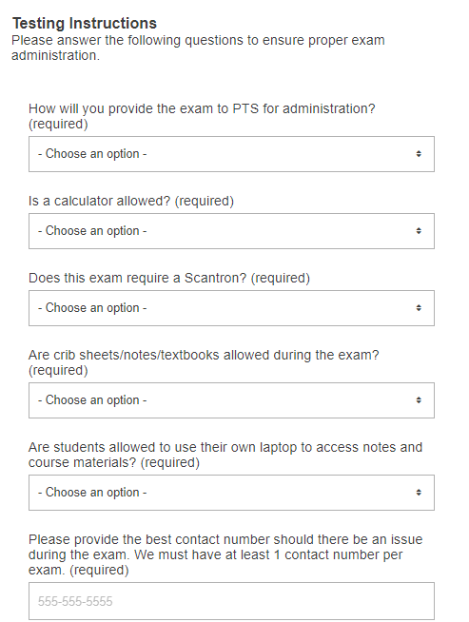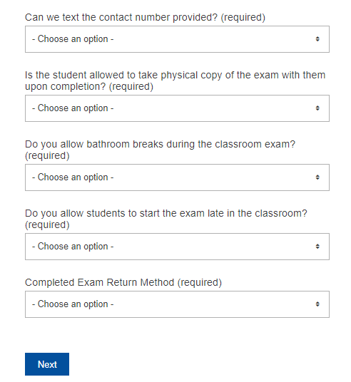

- Eligibility and Restrictions – If this TIF only applies to a specific student(s), you can type their Purdue Email address into this field. Only the student specified will be able to schedule their exams with these TIF parameters. If the TIF applies to ALL students with accommodations, leave this field empty.
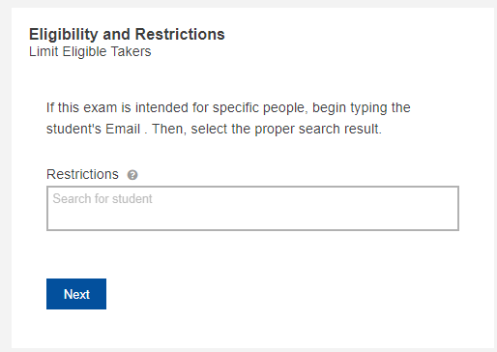

- Additional Information – Provide any additional information the proctors may need to know prior to administering the exam.
- Once you have completed all of the information, click “Submit” or “Submit and Print.” You will receive an email copy of your submission if it went through successfully.
