Danny Varghese, Mike Hurst, Aaron Hurley, Chris Rodgers
Math 490N Paper
Professor Cowen
29 April 2004

An In-Depth Look Into “A Model of Beta-Cell Mass, Insulin, and Glucose Kinetics: Pathways to Diabetes”
Sir William Bragg once said “The important thing in science is not so much to obtain new facts as to discover new ways of thinking about them.” In the paper “A Model of Beta-Cell Mass, Insulin, and Glucose Kinetics: Pathways to Diabetes, “ the authors Brian Topp, Keith Promislow, Gerda DeVries, Robert M. Murias, and Diane T. Finegood tried to do just that. Diabetes is a disease of the body that affects the regulatory system. There are three primary variables in the study of Diabetes. They are the beta-cell mass, insulin, and glucose concentrations in plasma. Existing models of glucose regulation incorporates only glucose and/or insulin dynamics. In this paper, they authors found a new way of thinking about diabetes by incorporating all three primary variables in their model. In this review of their article, we will discuss an introduction to Diabetes by further going into what Diabetes is and some more definitions. Next we will take a look at the development of the models of glucose, insulin and beta-cell dynamics. Third we will look at how these models behave, and the effects of parameter changes on these models. Finally, from these models, we can see how a person can get Diabetes, namely by three different ways. So what is Diabetes?
Diabetes is a disease of glucose regulation that is associated with the production, secretion and sensitivity to pancreatic insulin. The article is a good example of the marriage between biology and mathematics. Before the math is explored, it is important to develop a biological basis for research. Diabetes mellitus involves glucose regulation and often leads to hyperglycemia. There are two subcategories of diabetes mellitus. Type 1 diabetes is also known as juvenile onset diabetes because it usually manifests congenitally or early on in life. Type 2 diabetes is synonymous with adult onset diabetes. This form begins to infect individuals later in life around the age of forty but in some cases earlier. The importance of the research can be illustrated through the statistics. The Merck Manual of Diagnosis and Therapy states that 16.5 million people have been diagnosed with diabetes. It goes on to estimate 5.4 million addition patients who have not been diagnosed. Worldwide, 0.3% of the population has some form of diabetes. Aside from the daily morbidity, patients may experience complications such as blindness, amputation of limbs, coma, and death. In order to propose mathematical models of a test system, there must be an understanding of the anatomy.
The major organ involved is the pancreas. The pancreas lies in the abdominal cavity below and posterior to the stomach. The head is adjacent to the duodenum of the small intestine and the tail extends toward the spleen. This organ serves both exocrine and endocrine function. The exocrine refers to the acini cells production of digestive enzymes that are secreted into the small intestine. The article focuses on the endocrinology of the pancreas. Specifically, the research centers on the β-cells of the islets of langerhans. This highly vascularized area contains many types of cells, but the majority of these cells are β-cells. The blood source allows the hormones to be secreted directly into the blood where they act globally on the body at specific receptors. β-cells secrete, store, and produce insulin. Another cell type found in the pancreas is α-cells which secrete glucagon. This has the opposite effect as insulin. Insulin is a hormone that decreases blood glucose concentrations and increases glucose storage. This is done by either using the glucose for energy in a process termed glycolysis or by promoting storage of glucose in muscles through the production of glycogen. Glucose is a simple sugar that is broken down to form ATP. This is the basic unit of energy for the human body. The system is under control of a negative feedback loop. Figure 1 shows the schematic of the insulin-glucose loop. A negative feedback refers to a system in which the body is returned to homeostasis following some trauma or change by bringing a controlled condition back to normal. Homeostasis is a stable internal environment of the body and is desired. Glucagon works in the opposite manner by increasing blood glucose and promoting gluconeogenesis (production of glucose from precursors or ingested food).
Figure 1: (Taken from the Journal of Clinical Endocrinology)

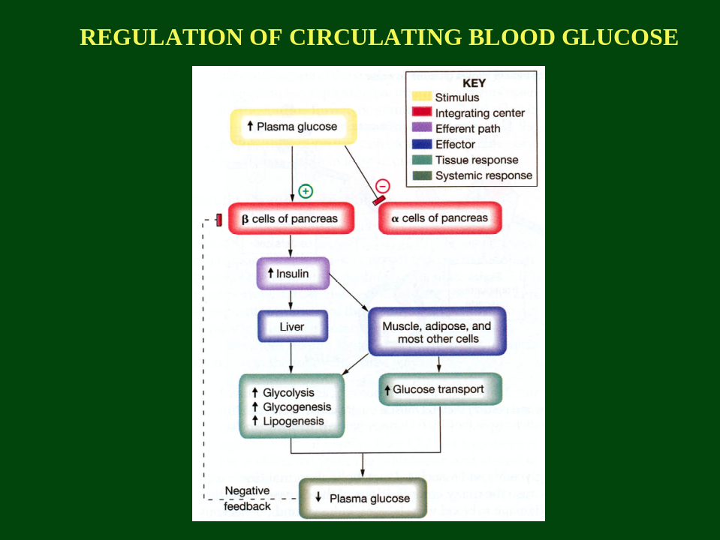

There are a few concepts regarding the physiological side of diabetes before the model can be discussed. First, is the state where the body is not responsive to insulin. This is known as insulin resistance and occurs in type 2 diabetics. Another facet of the condition is the blood glucose concentration. Hyperglycemia indicates elevated blood glucose (blood sugar); hypoglycemia refers to lower than usual blood glucose concentration; and normoglycemia describes physiologically healthy blood glucose level. With the basics in mind, the pathology, or route of action can be examined.
Diabetes is somewhat idiopathic, that is the exact cause is slightly ambiguous. However, the major factors are known. In type 1, the immune system attacks β-cells. This usually occurs in childhood. This type of disease in called autoimmune. In such a case, 80-90% of β-cell mass is lost. This naturally results in insufficient insulin production. Patients must regularly inject insulin to survive. Type 2 diabetes is associated with defects in insulin secretion and low β-cell mass. This reduces the disposal of glucose. Obesity induces and worsens the condition. Basically this is a defect in receptor or post receptor signaling. Additionally, β-cell mass may increase in order to compensate for insulin resistance. Treatments are primarily diet and exercise. Other causes of β-cell destruction include cancer, cystic fibrosis and other diseases. One cause of insulin resistance may be Cushing syndrome. With the foundation established, the mathematical model can take shape.
Historically, computational research on diabetes has centered on glucose and insulin levels or coupled glucose/insulin dynamics. The model in this article incorporates β-cell mass. The model proposed in made up of three dynamical systems: glucose, insulin, and β-cell mass. The glucose dynamic is basically the difference between production and uptake. Production refers to gluconeogenesis from stores or from digested food while uptake involves the use and storage of glucose. The derivation shows the final equation which includes the rate difference, glucose effectiveness, and insulin sensitivity.

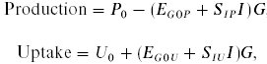

The insulin dynamic was an equation expressing the difference between secretion and clearance. The clearance of insulin is accomplished by the liver and kidney or by receptors for insulin. Secretion by pancreatic β-cells is expressed in a sigmoidal function where sigma represents the rate of insulin secretion.

The last component of the model is the β-cell mass dynamics. This is a function of the difference between formation and loss of β-cells. Formation of β-cells is primarily accomplished by replication from existing β-cells. They may also arise via differentiation from stem cells or by transneogenesis, however these methods were considered negligible for the sake of the study. The loss of β-cells is due to a programmed cell death known as apoptosis. Both of these equations are second degree polynomials depending on rate constants that are based on normalized values.

The model will show normal behavior of the system and allow single defects or combinations of defects to be scrutinized. Additionally, the research investigates the behavior of these equations described above.
In making the model, one needs to actually know what the model needs to be about. In this situation, we are using three (3) of the previous equations that we developed to create this model. The paper references these equations as equations (4), (8), and (12).
Equation 1
The first equation that we are going to talk about is the one of the rate of glucose secretion into the blood. This equation is,
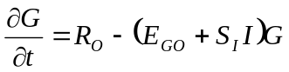.
This equation relates glucose uptake to glucose production. R_{o} is the net rate of production at zero glucose, G is the concentration of glucose in the blood, S_{I} is the blood insulin sensitivity, and I is the insulin concentration in the blood. As we can see from this equation, the rate at which glucose changes reaches a maximum when there is no glucose.
Equation 2
The next equation is the one that relates the rate of insulin secretion, glucose secretion into the blood, and the rate of -cell mass production and destruction. This equation is,
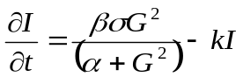.
In this equation,  is the beta cell mass,  is the maximum rate at which beta cells secrete insulin, k and alpha are constants, and 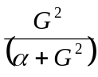 is the Hill Function.
Equation 3
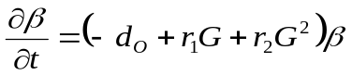
Equation three is an equation that relates beta cell production and death. This equation is given by,

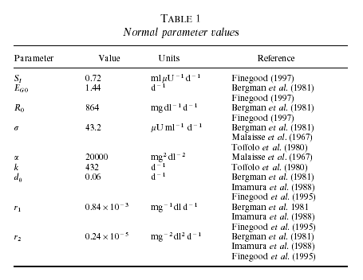
In this equation,  represents beta cell mass, d_{O} represents the death rate at zero glucose, and r₁ and r₂ are constants. This is a table of parameter values the authors used in the publication of this paper.
Intriguing Interpolations
We learn two things from these equations. The first of which is that the system can be broken up into fast and slow subsystems. The second item is that the number of parameters can be decreased from nine to eight. These are important because we can analyze the fast subsystems together, then the slow one; then we can make it easier to analyze due to fewer parameters.
Dynamics of Fast subsystems
When we analyze the fast subsystems, we need to generalize that the slower subsystem acts like a parameter, instead of behaving like a variable. This needs to be done because of the rate at which the slow subsystem changes with respect to the faster subsystems. The faster subsystems change with respect to minutes, whereas the slow subsystem changes on the order of a few days. This significant change of magnitude allowed the authors to assume the slow subsystem to be a parameter for this portion of the experiment. The fast subsystems we are talking about are the ones giving us what glucose and insulin are equal to. By deductive reasoning, we see the slow system is the one describing beta cell mass and how it changes with time. When talking about the dynamics of the system, we need to find the bifurcation diagrams of the system. As we did in class, we need to find the null clines of G’ and I’. We see when we change -cell mass the curve I’ shifts up and to the left. This causes a change in the fixed point, but we still keep just one fixed point.

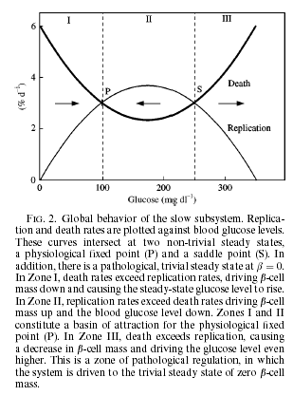
Dynamics of Slow subsystem
When we analyze the slower subsystem, namely the one dealing with beta cell mass, we cannot have it expressed as a parameter. This would not do much good for us. So, we shall plot it as a function of glucose level in the blood.

Section 1
As you can see in the graph to the right, it is divided into three sections. The first of these sections represents mild hypoglycemia. Hypoglycemia is the absence of glucose in your blood. This causes the death rates of beta cells to become less than the replication rates. When this happens, the glucose level is regulated back to the physiological fixed point (P). This is where the normal healthy person exists.
Section 2
Section two of this graph represents mild hyperglycemia. Hyperglycemia is the over-abundance of glucose in your blood. When this happens, the replication rates of beta cells increase, and overcome, the death rates. This, therefore, causes glucose levels to drop back to the physiological fixed point (P).
Section 3
Section three of this graph represents someone with extreme hyperglycemia. This is when the body cannot regulate the glucose level in the blood, and the beta cell mass is decreased to a steady state of zero beta cell mass. It is not possible to survive at zero beta cell mass. This section, section three, is where Type-II Diabetes occurs. Mathematically, what this means, is that The slow subsystem has two stable steady states and an unstable steady state that divides the areas of attraction for the two stable points.
Effects of parameter changes on the whole scheme of things
To describe the total effect of parameter changes on the whole system, we need to take it one step at a time. First, we will analyze the defects in glucose dynamics and what happens with those parameters. Second, we shall analyze the defects in insulin dynamics. And lastly, we will analyze defects in beta cell mass parameters to see what effect they have on the total system.
Defects of glucose dynamics
Defects in insulin sensitivity (a reduced S_{I}) ends up forcing the physiological fixed point and saddle points to a higher beta cell mass and insulin levels. Over the long run, if the insulin resistance does not fluctuate, then there are three effects: hyperinsulinemia, normoglycemia, and -cell hyperplasia. Basically these are an increase in insulin dependence, regulated glucose levels, and an increase in beta cell mass. Experimentally, when you augment R_{O}, you increase beta cell mass and insulin levels. Therefore we see that glucose dynamics have no effect on the model’s physiologically regulated glucose level, but it does affect the beta cell mass and insulin levels required to maintain normalized fasting glucose levels.
Defects of insulin dynamics
Defects in insulin dynamics can be caused by an increase in k, , or . An increase in k or  shifts the physiological fixed points and saddle point to higher beta cell mass values. An increase in  causes the physiological fixed points and saddle point causes the beta cell values to increase also. Thus we can see that insulin dynamics do not affect the glucose or insulin levels at the physiological fixed point. But, they do affect the beta cell mass required to maintain normalized glucose and insulin levels.
Defects of beta cell mass dynamics
With the beta cell system, the slower system, the authors determined that the beta cell mass parameters are what determine the number of fixed points in the system. They also determine the glucose levels at the physiological fixed points and saddle point. For example, if d_{O} increases, it will cause the parabola to shift upwards, thus causing a change in stable fixed points (if moved high enough) from two to zero.
Previously in this paper the authors defined two stable fixed points in the βIG model – a physiological point, corresponding to normal conditions for a non-diabetic, and a pathological fixed point, corresponding to zero β-cell mass and high levels of glucose. In the latter state the subject is diabetic. This section of the paper describes three different ways within the βIG model that the subject could move from the physiological point to the pathological. Evidence from other papers shows that these pathways could indeed be taken in real life, although more research is needed to verify this. The three pathways are called regulated hyperglycemia, bifurcation, and dynamical hyperglycemia and are described separately.
Regulated Hyperglycemia
A small defect in the β-cell mass parameters can change the β-cell mass at the stable points, as shown in Figure 1. The result is that the physiological fixed point is now located in the hyperglycemic region, meaning the patient will be diabetic even though she has not moved to the pathological fixed point. This is referred to as “regulated hyperglycemia.” The authors cite the results of Bernard et al. (1999) to confirm this possible pathway. Bernard’s rats retained the ability to adjust β-cell birth and death rates, and yet in the absence of external influence they remained diabetic. Another way for this to occur is if the body is totally unable to regulate the β-cell mass, which effectively reduces the βIG model to only the fast insulin/glucose subsystem. If there is any problem with the G or I parameters, the physiological fixed point can again be relocated to the hyperglycemic region. The authors cite the data of Kloppel et al. (1995) in which diabetic subjects had normally sized pancreases, implying that a non-responsive β-cell mass may have been the cause of their hyperglycemia.
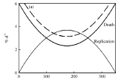
Figure 1 – Regulated hyperglycemia, caused by a small defect in the β-cell mass parameters. As a result, the physiological fixed point is relocated to the hyperglycemic region.

Bifurcation
In a second case, the subject can enter the pathological state because the physiological fixed point has been eliminated. The root cause is a large defect in β-cell mass parameters, resulting in a saddle-node bifurcation as depicted in Figure 2. The physiological fixed point, shown by the solid line in the lower-right corner of the graph, adjusts as parameter r1 changes. However when r1 falls below r1c (the bifurcation), the physiological fixed point no longer exists because β-cell death will be faster than replication regardless of the glucose level. The result is a catastrophic loss of β-cell mass as the subject falls to the physiological fixed point (represented by the solid line in the upper left hand corner.) As noted by O’Brien et al. (1996), an autoimmune attack on the β-cell mass alter the replication parameters so that the system would move below the bifurcation. The authors suggest that this may be the pathway taken in such cases.
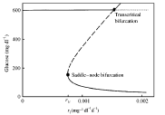
Figure 2 – A bifurcation diagram for a system with large scale defects in β-cell mass regulation. When parameter r1 falls below r1c, the physiological fixed point disappears.

Dynamical Hyperglycemia
A third way for the system to leave the physiological fixed point is for there to arise a runaway need for increased β-cell mass which exceeds the body’s ability to replicate β-cells. For example, perhaps resistance to insulin is increasing very quickly. Such a situation is shown in Figure 3, below. In zones I and II, the body regulates itself to stay in a normoglycemic state. In zone III, β-cell mass falls to zero and the subject is diabetic. The dashed lines represent two possible paths that the system could take. In the top path, the insulin sensitivity (S_{I}) is decreasing slowly enough that the β-cell mass can compensate by increasing, keeping the system in Zone II. However, in the bottom path, S_{I} is decreasing so quickly that the β-cell mass cannot keep up and the system is forced across the separatrix into Zone III, at which point diabetes begins.
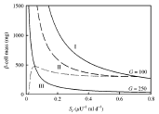
Figure 3 – Relates β-cell mass to insulin sensitivity. The graph depicts two possible paths that the system could take. In one the body enters zone III, but in the other normoglycemia is maintained.
So in this review, we have learned numerous things about Diabetes. First it is a disease of the body that affects the regulation of glucose. There are three primary variables when dealing with the discussion of the disease. Existing models only incorporate glucose and/or insulin dynamics, but the models discussed by these authors take into account all three primary variables. There are two types of diabetes, one found usually in children and the second type usually found in adults. Three equations were looked at, specifically, glucose, insulin and beta-cell mass concentrations in the blood. What did we learn from those equations? That the model can further be broken down into fast and slow subsystems. The fast being the glucose and insulin systems and the slow being the beta-cell mass system. There were also three defects associated with those models. Regulated Hyperglycemia is when the physiological fixed point is moved to the hyperglycemic level. Bifurcation is when the fixed and physiological points are removed. Finally Dynamical Hyperglycemia is when the beta-cell mass is pushed into the pathological region (diabetic state). So with these new models, explanations of the models and a further look into how a diabetic comes about both mathematically and biologically, we think Sir William Bragg would be proud of these authors that found a new way of thinking about previous facts discovered.

