Sean Devlin
Nate Hribar
Sashi Marella
MA490N/BIOL595N Spring 2004 Report
Professor Carl Cowen

Detailed Model of Intersegmental Coordination in the Timing Network of the
Leech Heartbeat Central Pattern Generator
Sami H Jezzini, Andrew A.V. Hill, Pavlo Kuzyk, and Ronald L. Calabrese
Journal of Neurophysiology 91: 958–977, 2004.

Biology Background
We begin with background on biology of the leech, which is an annelid and like other members of its phylum, it has a segmented body plan (Fig 1).
Fig 1.The Medicinal leech: Hirudo Medicinalis
Fig 2 From Wenning, 2004. Consecutive images of midbody segments 8 and 10 to show the blood flow through the lateral hearts (ventral view, anterior to the left) in an intact juvenile leech. The right heart (R, bottom) is in the synchronous coordination mode, the left heart(top, L) in the peristaltic coordination mode. Yellow dots are juxtaposed along the heart sections filled with blood.

The leech has two longitudinal tubes (Fig 2) which by means of peristaltic and synchronous movements facilitate the circulation of blood to all of its individual segments. Each longitudinal tube is considered to be an annelid's rendition of the more familiar form; the mammalian heart. The two hearts have individual segments which can constrict or relax. The constriction or relaxation of all the segments when viewed together is pattern-like. The constriction and rate of constriction of individual heart segments are controlled by a group of motor neurons which in turn are controlled by a heart central pattern generator (CPG).

The leech nervous system is segmented (Fig 3). Each body segment is catered to by a group of neurons whose soma is contained in a neuropil or a ganglion (a collection of neuron cell bodies). The neurons of a single ganglion innervate skin and other organs in that particular ganglion (these processes form the roots) and also extend axons to the adjacent segments where they either synapse with neurons in that ganglion or innervate organs. These axons extended into the adjacent segments together form a connective, resulting in a structure called the nerve chord consisting of continuous chain of connectives interspersed with ganglia.
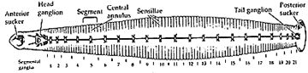
Fig 3 From Blackshaw and Nichols, 1995. Segmented Nervous system of the leech

The Heart CPG timing network (Fig 4, A) consists of paired inhibitory neurons in the first to seventh intersegmental ganglia. A subset of this network, namely 4 pairs of bilaterally symmetrical neurons in the first four ganglia form the heart beat timing network. Any neuron which is a part of the heart CPG network is called as heart neuron(HN) and is indexed by the side of the body and the segment in which its soma lies. For example; HN(L,3) suggests that the neuron soma is on the left side in the third segment. The first two segments contain cells which are of the equivalent function, viz: HN(L,1);HN(R,2);HN(L,2) and HN(R,2). They extend axons that reach into the third and the fourth segments. These axons have initiation sites in each of these segments. It is important to note that the HN(1) and HN(2) neurons cannot initiate spikes in the ganglion.

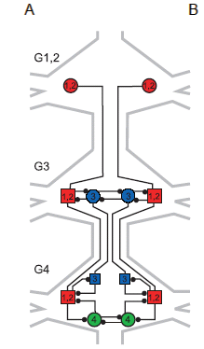
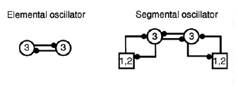
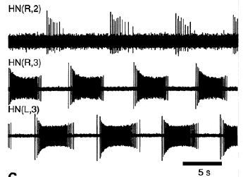
A
B
C

Fig 4. A. From Jezzini, 2004. The timing network of the leech heartbeat central pattern generator. The timing network contains 4 pairs of bilaterally symmetric interneurons that have cell bodies in the first 4 midbody ganglia. There are 2 segmental oscillators located in the 3rd and 4th ganglia. The coordinating interneurons of the first 2 ganglia are functionally equivalent and are, therefore, combined in representation. Open circles represent cell bodies, open squares represent sites of spike initiation, and small filled circles represent inhibitory synapses. B. From Hill, 2001. The electrical activity of three heart interneurons recorded extracellularly from a chain of ganglia (head brain to G4). Note the oscillatory pattern of firing C. From Hill, 2001. A diagram of the elemental and segmental oscillators of the third ganglion.

The third and fourth segments contain a single pair of bilaterally symmetrical neurons each, Viz: HN(L,3);HN(R,3);HN(L,4)and HN(R,4). HN(L,3) and HN(R,3) make reciprocally inhibitory synapses onto each other, and so do HN(L,4) and HN(R,4). The initiation sites of HN(L,1);HN(R,2);HN(L,2) and HN(R,2) have mutually inhibitory connections with the ipsilateral neurons in the third and the fourth segment. HN(L,3) and HN(R,3) extend axons into the fourth segment where the axons have an initiation site. This initiation site has a mutually inhibitory connection with the initiation sites of the ipsilateral HN(1) and HN(2) neuron initiation sites. Spikes in the HN(3) neurons are normally initiated in the third ganglion but can be initiated in the fourth segment as well.

Due to their reciprocally inhibitory synapses the pair of HN(3) neurons can produce oscillations (Fig 4, B). This is the smallest group of cells that can produce oscillations and hence are called the elemental oscillator (Fig 4, C). The HN(4) neurons are also considered as an elemental or half-center oscillator. Each single neuron of an elemental oscillator is called as oscillator neuron. Each oscillator neuron also makes a reciprocally inhibitory synapse unto the ipsilateral intiation sites of HN(1) and HN(2). This combination of a pair of oscillator neurons and the initiations sites of HN(1) and HN(2) neurons can also produce oscillations when kept in isolation and is called as a segmental oscillator (SO) (Fig 4, C). Note that the two segmental oscillators are not identical. The segmental oscillator comprising of the HN(3) neurons extends axons into the fourth segment which makes further contacts as mentioned above. HN(1) and HN(2) neurons are also called as coordinating neurons. When released from synaptic inhibition from the ipsilateral oscillator neuron, these neurons exhibit tonic firing but don’t show bursting activity. The bursting activity seen in-vivo is thought to arise as a result of the periodic inhibition from the ipsilateral oscillator neuron. During recordings it has been found that their firing frequency during bursts is lower compared to the oscillator neurons and that it tends to decrease towards the end of a single burst (Spike frequency adaptation).

The oscillator neurons are known to burst even in the absence of synaptic inhibition. The oscillator neurons oscillate from bursting to inhibited phase with a period of 10-12 seconds. Once an oscillator neuron starts firing, it essentially inhibits its contralateral counterpart. For the presently inhibited cell to end its inhibited phase and start its bursting phase, it either has to be 'allowed' by its contralateral counterpart to do so, or should actively escape its influence. The ‘escape’ is facilitated by the hyperpolarization-activated cation current (I_{h}). During synaptic inhibition, I_{h} activates relatively slowly and depolarizes the inhibited neuron, thus allowing for the transition into the burst phase. The ‘release’ of the inhibited neuron is allowed by the decline in the spike frequency in the contralateral oscillator neuron. Although it has been proposed that both these mechanisms are used but the escape mechanism contributes most. Oscillator neurons are presynaptic to the heart neurons which inturn form a neuromuscular junction with the heart muscles.

One of the most important features of a CPG is its ability to produce pattern like output. This pattern arises due to a phase difference in the various parts of the organ that is involved in the behaviour. In the example of food being swallowed by an organism, its food-tube should be able to constrict the circular muscles located throughout its length in a sequential manner to facilitate the passage of food from the end of the oral cavity (mouth) to the stomach. In order for the muscles to constrict and relax in a sequential manner the motor neurons should also show sequentiality (phase difference) in their activity. Such phase differences between segments have been observed in the leech heart-timing network too. Understanding the properties of the phase differences and the parameters which control them needs a basic understanding of the individual neurons involved. There are two basic types of experiments that have been previously conducted in live preparations and in models. The first type of experiments are the driving experiments where the cell in question is driven (faster or slower than its inherent period) by intracellular currents and the effect of the system, is observed. This type of experiments are called as the open loop experiments as the information from the driven cell is passed on to the follower cell but not in the backward direction as the driven cell’s period is tightly controlled by the stimulation protocol. The second type of experiments are the entrainment experiments where the membrane properties of a single cell are changed inorder to effect a change in its period and hence its phase. The effects of such a change on the system are then observed. Such experiments are called as closed loop experiments as now information can flow in both directions as the cell can respond to signals from its follower cell (as there is no longer a stimulation protocol preventing the cell from responding to other cells).
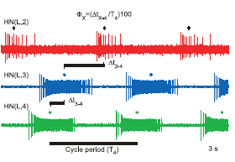
Fig 5. From Jezzini, 2004. The electrical activity of 3 heart interneurons recorded extracellularly from a chain of ganglia (head brain to G4). The heart interneurons are labeled HN and are indexed by body side and midbody ganglion number [e.g., HN(L,3)]. Phase (Φ_{x}) of an interneuron X with respect to the G4 oscillator interneuron was calculated, on a cycle by cycle basis, as the difference in the median spike times (∆t_{X-4}) divided by the G4 cycle period (T4), and then multiplied by 100. A positive phase value indicates that the G4 oscillator leads in phase.

The data obtained from these experiments are used to calculate parameters of interest (Fig 5). The cycle period or time period (T) is calculated as the interval between the median spike to median spike of consecutive bursts. The time period can be calculated for a single cell or a network. In case of a network all the cells are taken in to consideration and the first median spike of the cell which intiates firing first is considered as the start point and the second median spike of the cell that intiates firing last is considered as the end point. The phase (Φ) of a given heart neuron is calculated with respect to a reference cell as the ratio of the difference of the median spike time of the neuron in question and the reference cell to the time period of the reference cell and expressed as a percentage. Previous experiments have shown that in the coordinating heart interneurons most of the spikes were evoked at the G4 site. Hence it has been proposed that the network functions in a symmetric fashion as opposed to an asymmetric fashion in the biological system.
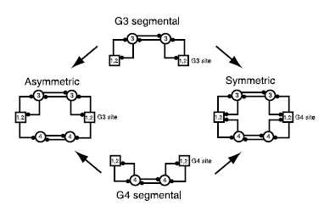
Fig 6. From Hill, 2002. The timing network can be conceptualized as either a symmetric network or an asymmetric network.

It has been predicted theoretically and shown experimentally that the periods of the uncoupled oscillators can predict the phase differences between the G3 and the G4 oscillators in the recoupled network and that the faster oscillator determines the cycle period (Fig 7). Masino et al, 2002b have shown that when the third and fourth ganglia are uncoupled using sucrose knife technique (a technique which allows the reversible blockage of conduction without actual physical separation of the ganglia) and then recoupled, the phase difference between the G3 and G4 segmental oscillators can be predicted by the difference in the inherent period differences between the uncoupled segmental oscillators (Fig 7A). The period of the recoupled system was better predicted by the uncoupled cycle period of the faster oscillator (Fig 7B). The group also showed that when the inherent periods of the cells were either decreased using Molluscan Myomodulin (MM) or increased using Cesium ions (Cs⁺), the period differences between G3 and G4 predicted the phase differences between the G3 and G4 segmental oscillators (Fig 7C). The period of the recoupled system was also better predicted by the uncoupled cycle periods of the faster oscillator (Fig 7 D).
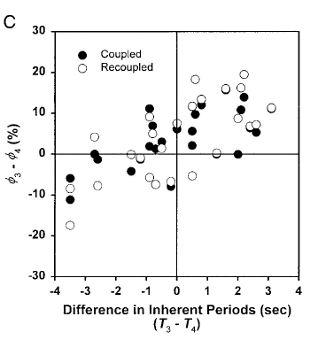
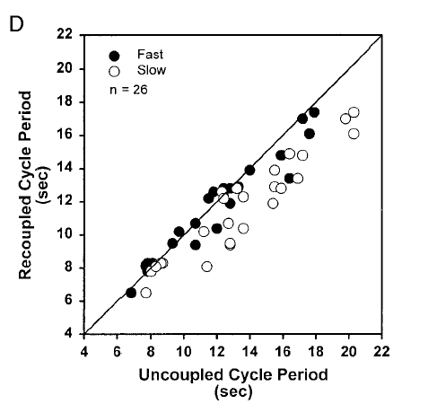
A
B
C
D
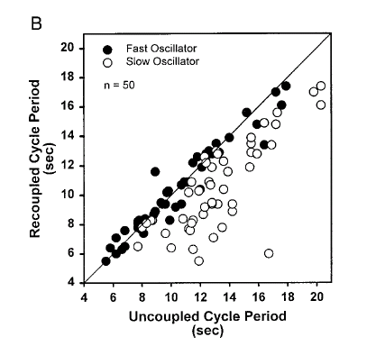
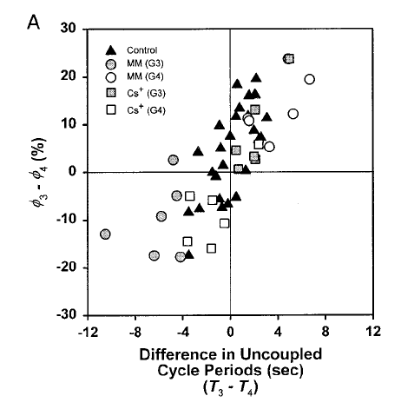
Fig 7. From Masino, 2002b. A. Recoupled G3-G4 phase relationships vs. the differences in inherent cycle period between the G3 and G4 SO’s. Inherent period differences between the uncoupled segmental oscillators predict the coupled and recoupled G3 to G4 phase differences. The inherently faster uncoupled oscillator led in phase and established the cycle period in the recoupled timing network.B. Recoupled timing network cycle periods vs. the inherent cycle periods of the uncoupled segmental oscillators. For each preparation the faster and slower of the 2 oscillators was determined, and they were plotted separately. The recoupled cycle period of the timing network was established by the cycle period of the inherently faster uncoupled oscillator. C. Recoupled G3-G4 phase relationships vs. differences in cycle period between the G3 and G4 segmental oscillators. Period differences, both naturally occurring and altered by myomodulin (MM) or Cs) between the segmental oscillators predict the recoupled G3 to G4 phase difference. The faster (inherent or altered) uncoupled oscillator led in phase. D. Recoupled timing network cycle periods vs. the inherent cycle periods of the uncoupled segmental oscillators. For each preparation the faster and slower of the 2 segmental oscillators was determined, and they were plotted separately. The recoupled cycle period of the timing network was established by the cycle period of the faster (inherent or altered) uncoupled oscillator.

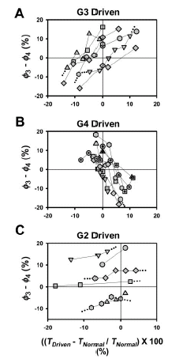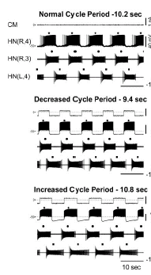
A
B

Fig 8. From Masino, 2002a. A. Plots of the G3 to G4 phase relationships versus changes in the timing network cycle period. In each preparation, one of the paired oscillator interneurons in G3 or G4 is driven to periods both faster and slower than the normal cycle period. The G3 to G4 phase relationship at each driven period is plotted against the change in period. B. The timing network is entrained to periods faster and slower than the normal cycle period by driving one of the paired oscillator interneurons in G4. Simultaneous intracellular [HN(R,4)] and extracellular [HN(R,3) and HN(L,4)] recordings of oscillator interneurons are illustrated in each panel. Normal Cycle Period, The cycle period (10.2 sec) of the timing network is regular, and the activity of the heart interneurons is phase locked. Decreased Cycle Period, The HN(R,4) interneuron is driven by current pulses to a period (9.7 sec) that is faster than the normal cycle period (10.2 sec). Increased Cycle Period, The HN(R,4) interneuron is driven by current pulses to a period (10.8 sec) that is slower than the normal cycle period (10.2 sec).

The group also performed driving experiments (Fig 8B) in live preparations. It was observed that there was a near linear relationship between the percent change in the period of the driven oscillator (Fig 8A). It was also shown that driven oscillator can lead or lag behind the undriven oscillator depending on whether the driven oscillator was faster or slower than the undriven oscillator. A previously published model of the network had not allowed the driven oscillator to lag behind the undriven oscillator (Hill 2002, Fig 9). The results indicated that the G4 oscillator could produce entrainment of the entire network over a relatively narrower range than the G3 oscillator (Fig 8A). This suggested that there was a functional asymmetry in the G3 and G4 oscillators in the live preparation. This result directly suggested that although the hypothesis that the network functioned in a symmetrical manner was based on experimental data (most of the spikes are elicited from the G4 spike initiation sites), the system still could still functioned in an asymmetrical manner.

The previous models were based on the symmetrical model and also didn’t allow the driven oscillator to lag behind the undriven oscillator. In order to capture the final details of the biological system the group built a model which incorporated the spike adaptation property of the coordinating neurons and also built an asymmetric model which used multicompartmental cables for the coordinating neurons.

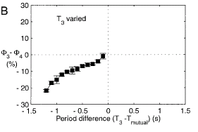
FIG 9 From Hill, 2002. The canonical symmetric network can only be driven faster than its mutually entrained period. A driving stimulus was applied to HN(L,3). B. entrainment only occurred when the driven oscillator led in phase.

Mathematical Modeling
The paper is focused on the modeling of the oscillator interneuron and the coordinating heart interneuron as well the improvements on the previous model (Hill 2001). The first is the oscillator heart interneuron. These are neurons found in the the 3rd or 4th ganglion. The dynamics of the membrane potential are as follows:
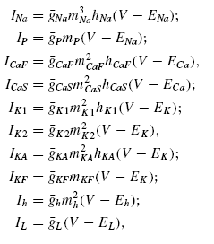
C dV/dt = -(INa + IP + I CaF + ICaS + Ih + IK1 + IK2 + IKA + IKF + IL + ISynG + ISynS – Iinject). C is the total membrane capacitance. Iion is the intrinsic voltage-gated current. ISynG is the graded synaptic current. ISynS is the spike-mediated synaptic current from all presynaptic sources. Iinject is the injected current. Flux through voltage-gated and ligand-gated channels into the neuron are shown with negative current where as injected current is positive. The remainder are the voltage-gated currents.

There are five inward currents. INa is the fast Na+ current. IP is the persistent Na+ current. ICaF is the fast, low threshold Ca2+ current. ICaS is a slow, low-threshold Ca2+ current. Finally, Ih is a hyperpolarization-activated cation current. There are three outward currents. IK1 is a delayed rectifier K+ current. IK2 is a persistent K+ current. IKA is a fast transient current. The previous model (Hill 2001) included an additional outward FMRFamide activated K+ current. This current (IKF) had a maximum conductance of 0, so essentially it did not do anything of great importance and so it was removed for the new model. Further, gion is the maximal conductance and Eion is the reversal potential. The use of maximal conductance is used to achieve desired spiking activity. Also, m and h are activation and inactivation variables and are governed by a further set of differential equations. (Angstadt and Calabrese 1989, 1991).
The hyperpolariztion-activated cation current accounts for the ability of the inhibited neuron to escape from inhibition. Essentially, it works with the persistent Na+ current to depolarize the inhibited neuron. When this neuron escapes inhibition, it then inhibits the currently bursting neuron. This is the key to enabling the system to oscillate appropriately. After this cycle, a new burst begins and the ICaS and IP then work together to sustain it. The other possibility is release. Rather than the inhibited neuron escaping inhibition, the bursting neuron releases the inhibited neuron. However, in the leach this transition is mainly through escape.
The exchange between the inward and outward currents determines the amplitude of the wave. IK1 and IK2 outward currents work separately to limit the amplitude of this slow-wave.
Between a pair of oscillator interneurons within the same segmental ganglion exists two different types of synapses. The first are plastic spike-mediated synapses which are modulated by slow changes in membrane potential and are a function of the influx of presynaptic Ca2+ through high-threshold Ca2+ channels (Hill 2003). The synaptic current is defined by:

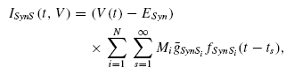
V is the presynaptic voltage. GsynSi is the maximal synaptic conductance of the synapse and is modulated by further variables. Mi is the modulation variable of the synapse and is a function of further equations and ts is the time of the spike event.
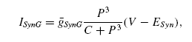
The second type of synapse is graded synapses which work substantially differently than the spike-mediated synapses. These synapses are a function of a drastic change in potential of a presynaptic cell. Essentially, the presynaptic cell has an increase in potential and releases neurotransmitter into the synapse without an action potential ever occurring. Because the amount of neurotransmitter released is much less, the graded synapse is dependent upon an influx of presynaptic Ca2+ through low-threshold Ca2+ channels. The graded synaptic current is as follows.
C is a constant with C = 10^-32 coulombs^3) and P is in coulombs. The other variables are similar to the above.
The neurons that originate in the 1st or 2nd ganglion are the coordinating heart interneurons. The dynamics of the membrane potential for the coordinating heart interneurons are as follows:
-C dV/dt = (Σ Iion + Σ Isyn + IL – Iinject)
C is the total membrane capacitance. Iion is an intrinsic voltage-gated current. IL is the leak current. ISyn is a synaptic current, and Iinject is the injected current.
The coordinating interneurons link to mutually inhibitory pairs of oscillator interneurons. This pair is known as a half-center oscillator. These coordinating interneurons are modeled as single intersegmental cables G1 and G2 shown in Figure 10 below.
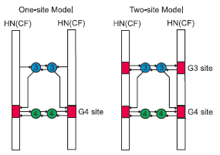
Fig 10. From Jezzini, 2004. Open circles represent cell bodies, vertical open bars represent conducting and passive regions of the intersegmental cable known as coordinating fibers, and colored areas in these bars represent spike initiation sites. Small filled circles represent inhibitory synapses

Changes in the Current Model
In the 2004 model which differs from (Hill 2001), the coordinating fibers are multicompartmental. They are separated into 150 compartments, and each coordinating fiber contains spike initiation sites. In the one-site model there are two total spike initiation sites and four in the two site model (two at G3 and two at G4), each capable of spontaneous activity. In order to more accurately model the living system of coordinating interneurons, multiple initiations sites are used as well as initiation sites that are adapting and non-adapting. Adapting sites allow for spike frequency to decline throughout the cycle which is evident in the living system. This adaptation is seen in Figure 11 below.
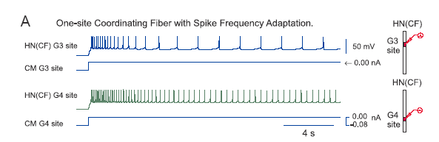
Fig 11. From Jezzini, 2004. Interaction between spike initiation sites and spike frequency adaptation in the model coordinating fibers. The icons at right represent the configuration of each simulation.

In this specific instance in a one-site model the the adaptation is apparent through
the frequency declining throughout the cycle.
The effect of this adaptation change becomes relevant in Fig 12, a graph of a two site model.
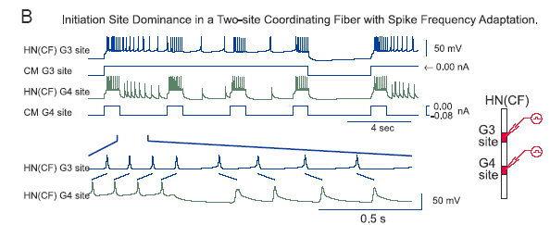
Fig 12. From Jezzini, 2004. Interaction between spike initiation sites and spike frequency adaptation in the model coordinating fibers. The icons at right represent the configuration of each simulation.

In the previous model, (Hill 2001) the initiation sites fired at a constant rate rather than rebounding and showing spike frequency adaptation. They rebound after receiving inhibitory signals from the oscillator interneurons. The above graph demonstrates the effects of this change.
Both inhibitory sites are released from hyperpolarization. The G4 site bursts when it is no longer hyperpolarized as seen throughout the graph. During each interval when the G4 site is hyperpolarized, the frequency of the G3 graph declines but still dominates the G4 cycle. The important note however is that the G3 spike frequency declines fairly consistently even through the repressive bursts from the G4 site, which shows that spike frequency adaptation and spiking activity are independent of one another. The bottom graph represents the causal correlation between G4 and G3 with the slanted lines pointing out the specific interactions to reiterate the ideas expressed earlier.
As stated in the Hill paper in regards to the model of the previous timing network “the timing network ignored some details of the firing patter of the coordinating neurons and their synaptic interactions with the oscillator interneurons” (Jezzini 2004). They explicitly state that in this paper they “explore the behavior of a model that more realistically represents the coordinating interneurons as multicompartmental cables, which have properties such as spike adaptation and multiple spike initiation sites.” (Jezzini 2004).

Experimental Results
The first experiments that were completed were experiments using the 1-site model with spike frequency adaptation (SFA). This model was used because it has the same functional symmetry as the symmetric model of Hill et al 2002 (because G3 and G4 oscillator interneurons both inhibit the only spike-initiating zone). In this way, 1-site model experiments can be seen as essentially experiments on the symmetric model with the addition of spike frequency adaptation (i.e. without the addition of the multi-compartmental modeling of the coordinating fibers (CF’s)).

1-site Entrainment
In the 1-site entrainment experiments, the 1-site model with spike frequency adaptation performs better than the symmetric model by virtue that the slower oscillator now does influence the period of the coupled system (T_{c}). (Previously in Hill et al 2002, when G3 and G4 segmental oscillators with different periods were coupled, T_{c} was equal to the period of the faster segmental oscillator. This does not correspond with behavior in the living system, however.) See Figure 13: the ability of the slower G3 oscillator to influence T_{c} results from it lagging the faster G4 oscillator in phase, resulting in the high frequency part of the coordinating fiber (CF) bursting occurring later in the inhibited phase of G4. G4 cannot begin bursting until this inhibitory firing of the CF’s slows to a given frequency – thus, G4 can be slowed by G3 lagging in phase and by spike frequency adaptation.
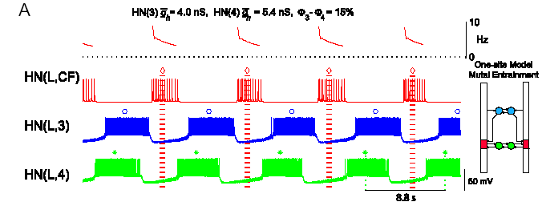
Fig 13. From Jezzini, 2004. Slower oscillator now influences system T

However, in the 1-site experiments, as in the experiments in the symmetric model, the faster segmental oscillator still cannot accelerate the coupled system past the half-center period (T_{hc}) of the slower segmental oscillator.
1-site Driving
In driving experiments for the 1-site model, the results from driving the G3 segmental oscillator and those from driving G4 were identical. Additionally, the range of periods to which the 1-site model system could be entrained was fairly symmetric (Figure 14). However, in the biological system, G3 has the ability to entrain the system over a much wider range of periods than G4 (Figure 15). Additionally, the range of periods to which G3 can entrain the biological system is much more symmetric than that of G4.
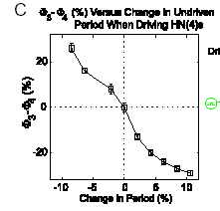
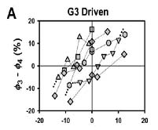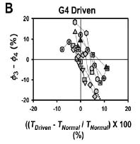
Fig 14 From Jezzini, 2004. G4 driving 1-site model (G3 performs identically)

Fig 15A,B From Masino & Calabrese ,2002c. Driving G3 & G4 in biological system

2-Site Experiments
Because the 1-site model experiments corrected some but not all of the inconsistencies between the symmetric model and the biological system, driving and entrainment experiments were done on the 2-site system as well. These experiments essentially tested the effects of adding both spike frequency adaptation and multicompartmental coordinating fiber modeling with 2 spike-initiating sites. The addition of a second spike-initiating site yields an asymmetric model (although the periods of the half-center oscillators of G3 and G4 are identical, the average firing frequency of the G3 CF spike initiation site is less than that of G4, leading to a shorter period for the G3 segmental oscillator (T_{3S}) than for G4 (T_{4S}).

The essential difference between the 2-site model and the 1-site model is that in the 2-site model, G4 oscillator interneuron firing reduces coordinating fiber activity (G3 CF sites are still active), whereas in the 1-site model, G4 oscillator interneuron firing eliminates CF activity. This change has a significant effect on the behavior of the 2-site model. In both models, G3 oscillator interneuron firing eliminates CF activity.

2-Site Entrainment
Because of the asymmetry of the 2-site model, g_bar_h was varied separately for the G3 and G4 oscillator interneurons (thus varying separately T_{3S} and T_{4S}) for the 2-site entrainment experiments.

When g_bar_h was varied for G4, several results obtained. If G4 leads G3 (T_{4S} > T_{3S}), it can at most accelerate the period of the coupled system (T_{c}) to T_{3S} (Figure 16). The reason for this is that G4 oscillator interneurons can only remove coordinating fiber inhibition to G3 to the level that it would see as an independent segmental oscillator. If G4 lags, however, it is very ineffective at slowing the period of the coupled system. This follows for two reasons – the first is that the leading G3 tends to accelerate the system via removal of CF inhibition. The second reason is a new acceleration mechanism available to G3 in the 2-site model, which the authors have termed “early burst termination.”

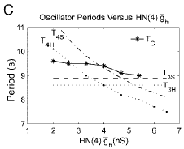
In the case of the waveforms in Figure B below, early burst termination takes place when the leading left G3 interneuron stops firing, causing the left G3 coordinating fiber spike-initiating sites to be released from inhibition and begin firing. These then provide inhibition to the end of the ongoing left G4 burst (see circle and arrow highlight in Figure 17), decreasing the frequency of the left G4 oscillator interneuron. The right G4 oscillator interneuron then escapes inhibition from the left G4 neuron whose inhibitory firing frequency has just been reduced. The right G4 oscillator interneuron then begins bursting, thus terminating the G4 left oscillator interneuron’s burst early.
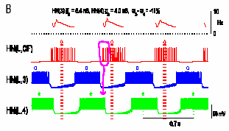
Fig 16 From Jezzini, 2004. Coupled system T vs. G4 maximum conductance
Fig 17 From Jezzini, 2004. Early burst termination due to G3 CF site inhibition of ipsilateral G4 oscillator interneuron, allowing escape of contralateral G4 oscillator interneuron

In summary, there were two main differences between entrainment experiments in the 1-site and 2-site models. First, because the G4 oscillator cannot inhibit G3 coordinating fiber spike-initiating sites, the coupled system run no slower than T_{3S}, regardless of whether g_bar_h is varied for G3 or G4. This contrasts to the 1-site system, where G4 can very effectively slow the coupled system. More generally, when the period of the G3 segmental oscillator is varied, it very strongly controls the period of the coupled system when G3 leads, and less strongly controls it when G3 lags (Figure 18). When the period of the G4 segmental oscillator, however, is varied, it only moderately controls Tc when G4 leads – when G4 lags, it exerts almost no control over Tc (Figure 19).
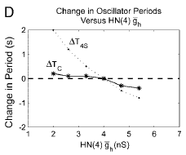
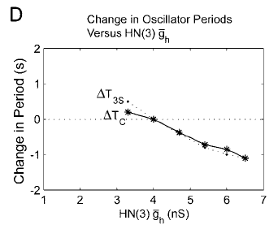

Fig 18 From Jezzini, 2004. T_{c} vs G3 conductance (T_{c} tightly follows T_{3S}).
Fig 19 From Jezzini, 2004. Tc only moderately influenced by T_{4S} when G4 leading – not at all when G4 lagging.

2-Site Driving
The addition of a second CF spike-initiating zone and resultant asymmetry in the abilities of G3 and G4 to silence CF inhibition yielded an asymmetry in driving experiments that was much more akin to that observed in the biological system than the functional equivalence of G3 and G4 in driving the 1-site model (Figure 20).

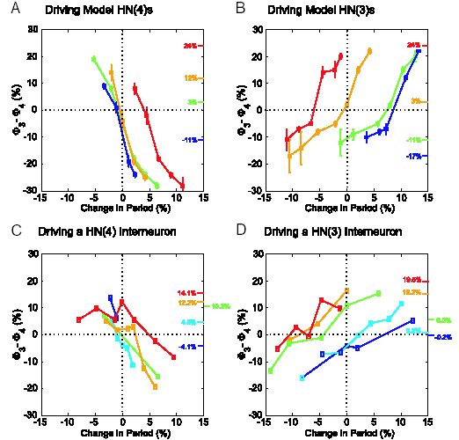

Fig 20 From Jezzini, 2004. Driving 2-site model and biological neurons.

Limitations of the 2-site model
Despite the accuracy in many respects of the 2-site model to the biological system, by virtue of the fact that it is a model, it still contains several limitations and inaccuracies. The first such limitation is that the slopes of the curves relating changes in period to phase while driving are much steeper for the 2-site model than for the biological system (Figure 20). The authors suggest that this indicates stronger CF inhibition in biology than in the model, because the biological data indicates that a small change in phase (in other words, in the amount of CF inhibition) results in a large change in period.

A second possible limitation concerns the fact that the range of periods on which the 2-site model was tested was a smaller subset of the range of periods obtained from the biological data (Figure 21). Given the complexity of the central pattern generator, it is not clear that the results presented in this paper will generalize simply to larger period ranges.
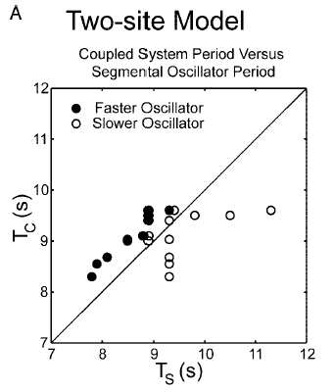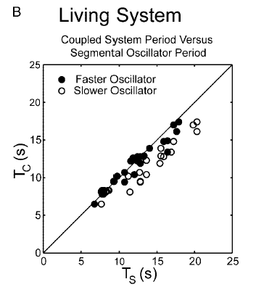
Fig 21A,B From Jezzini,2004. – Coupled T vs. SO T. The living system covers a much wider range of T_{S} than does the 2-site model.

References

Angstadt JD and Calabrese RL. A hyperpolarization-activated inward current in heart interneurons of the medicinal leech. J Neurosci 9: 2846-2857, 1989.

Angstadt JD and Calabrese RL. Calcium currents and graded synaptic transmission between heart interneurons of the leech. J Neurosci 11: 746-759, 1991.

Hill AAV, Lu J, Masino MA, Olsen ØH, and Calabrese RL. A model of a segmental oscillator in the leech heartbeat neuronal network. J Comput Neurosci 10: 281–302, 2001.

Hill AA, Masino MA, Calabrese RL. Model of intersegmental coordination in the leech heartbeat neuronal network. J Neurophysiol. 2002 Mar;87(3):1586-602.

S.H. Jezzini, A.A.V. Hill, P. Kuzyk, and R.L. Calabrese. Detailed model of intersegmental coordination in the timing network of the leech heartbeat central pattern generator, J. Neurophysiol. 91: 958 - 977, 2004.

Masino MA, Calabrese RL. Phase relationships between segmentally organized oscillators in the leech heartbeat pattern generating network. J Neurophysiol. 2002a Mar;87(3):1572-85.

Masino MA, Calabrese RL. Period differences between segmental oscillators produce intersegmental phase differences in the leech heartbeat timing network.
J Neurophysiol. 2002b Mar;87(3):1603-15.

Masino MA and Calabrese RL. A functional asymmetry in the leech heartbeat timing network is revealed by driving the network across various cycle periods. J Neurosci 22: 4418–4427, 2002c.

Wenning A, Cymbalyuk GS, Calabrese RL. Heartbeat control in leeches. I.Constriction pattern and neural modulation of blood pressure in intact animals.
J Neurophysiol. 2004 Jan;91(1):382-96. Epub 2003 Sep 17.

Contrast this to the symmetric model without spike frequency adaptation, where the CF inhibitory spiking takes place at a constant 4 Hz. With spike frequency adaptation, however, the beginning of the CF inhibitory spiking occurs at 7 Hz (and decays down) – this much higher initial frequency makes it much harder for G4 to escape inhibition and begin bursting – thus essentially slowing G4.

