Lorne Nelson, Daniel Wilhelm, Mike Scott, Adam Lugowski
Math 490N
Prof. Cowen

Analysis of “A Computational Model of Electrical Stimulation of the Retinal Ganglion Cell”

Introduction
Approximately 1.2 million people suffer from retinitis pigmentosa, a type of blindness characterized by photoreceptor degeneration (Greenberg et al. 1999). The clinical treatment of blindness generally relies on the use of alternate, functioning sensory modalities including audition and touch to compensate for the loss of vision. There has been some experimentation in grafting functioning photoreceptors into the retina (Humayun et al. 1996). However, due to the large number and complex connectivity of photoreceptors, as well as technical challenges in the actual procedure, this treatment currently appears unfeasible. Further, an alternative experimental approach has been to stimulate portions of the visual cortex (Humayun et al. 1996). This procedure also presents limitations, as the processing of visual information takes place in various locations of the cortex, and surgical access of the brain imposes its own risks. In cases of blindness resulting from the loss of photoreceptor function, the retinal ganglion cells remain intact. It has been shown that even without consistent stimulation the retinal ganglion cells experience little or no transsynaptic degeneration (Humayun et al. 1996). This allows for the possibility of electrical stimulation of existing ganglion cells by inserting a fine stimulating electrode into the eye positioned proximally to ganglion cells to elicit vision (Humayun et al. 1996).
It has been shown that a resolution of approximately 25x25 pixels is capable of eliciting a restricted visual field that is sufficient to permit mobility (Humayun et al. 1996). However, the anatomical organization of the ganglion cells on the retina complicates the ability to determine which ganglion cells are preferentially stimulated. The large area covered by ganglion cells with respect to the retina and the axonal convergence focused to the optic disc inhibits purposeful selection of a specific ganglion cell. Alternatively, determination of the threshold value at various locations on a retinal ganglion cell provides a method to determine which portion of the cell is most easily stimulated. The ability to discern which segments of the ganglion cells are most easily stimulated is crucial to achieve experimental repeatability and essential resolution. In the paper A Computational Model of Electrical Stimulation of the Retinal Ganglion Cell by R.J. Grrenberg, T.J. Velte, M.S. Humayun, G.N. Scarlatis, and E. de Juan Jr., a number of computational retinal ganglion cell models are employed to more precisely resolve which segments of retinal ganglion cells are most easily stimulated.
Essential to the development of these computational models of a retinal ganglion cells are the cellular properties that influence threshold values. The threshold value is the value of the membrane potential at which the influx of sodium exceeds the efflux of potassium resulting in an action potential. In general, this value is represented by a depolarization of ten to twenty millivolts. This value can be influenced by various neuronal properties. The density of voltage gated sodium ion channels for a given area of membrane dictates that area’s contribution to achieve the threshold depolarization. The greater the density of such ion channels, the greater the contribution to reaching the threshold depolarization. Generally, the axon hillock is considered to possess the greatest density of voltage gated sodium ion channels. Additionally important is the sensitivity of voltage gated sodium channels to a change in membrane voltage. The greater the sensitivity, the more rapidly the channel will be modulated and drive the membrane toward the threshold potential. The presence of myelin at or near the point of external stimulation can inhibit a threshold depolarization in response to an external electrical stimulation. In this particular model, myelin is not important, as ganglion cells within the retina are not myelinated. Utilizing these biological factors in conjunction with computational constructs, three models were developed and investigated. These three distinct models, closely based on actual cell morphology, include a linear passive model, a Hodgkin-Huxley active model with passive dendrites, and an all-active model utilizing five nonlinear ion channels with varying distributions and densities.

Specifics of the Model
A retinal ganglion cell with a long axon and a large dentritic field was chosen. For the majority of the calculations and simulations, a soma with 24μm diameter was used. However, some testing with a 10μm diameter soma was done in order to see if the size of the soma changed the ease with which an action potential could be elicited when externally stimulated. Empirical data was recorded regarding some of the neurons inherent physical attributes. These attributes are considered constant with regard to spatial and temporal changes within the cell. These values are as follows: membrane capacitance (C_{m} = 1μF/cm²) and membrane resistance (R_{m} = 50KΩcm²) (Greenberg et al. 1999).
In order to determine the part of the neuron that is easiest to stimulate, a method of dividing the neuron into different segments was necessary. For this reason the soma and cell membrane were segmented into compartments. An illustration of this compartmentalizing is nicely shown in Figure 1. The retinal ganglion cell was segmented into more than 9000 such compartments (Greenberg et al. 1999). The actual sizes of the compartments, as well as the time increments used in the math model for each compartment, were altered with respect to threshold. Compartment size and time increments were separately reduced until cross-compartment changes in threshold did not exceed 1%. Average compartment size was 1μm and average time increments of 25μs were used.
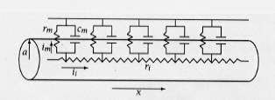
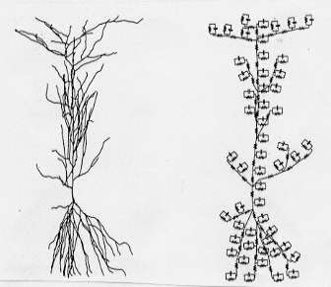

Figure 2

Figure 1

Each compartment was modeled as shown in Figure 3. The compartments consist of a membrane mechanism in parallel with a membrane capacitance. A resistance found between compartments is labeled as R_{a}. As mentioned earlier in this paper three models were used to describe the membrane mechanisms: a linear passive model, a Hodgkin-Huxley model with passive dendrites (HH), and an all active model (FCM) with five nonlinear ion channels distributed at varying densities. The linear passive mechanism simply reduces each compartment to a simple R_{m}C_{m} circuit with a leak modeled as a battery at -70mV (Greenberg et al. 1999). The second type of mechanism, HH, is the typical description given by Hodgkin and Huxley included in the simulation package NEURON. For this particular mechanism the dendrites are considered passive so Hodgkin-Huxley channel equations are only applied to the axon and soma.
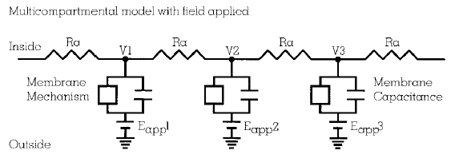
Figure 3
The third mechanism model, FCM model, consists of five ion channels dealing mainly with sodium, calcium and potassium. Each of the five channels has a conductance value associated with it based on what kind of channel it is. The five conductances are: a sodium conductance g_{Na}, a calcium conductance g_{Ca}, a delayed rectifier potassium conductance g_{K}, an inactivating potassium conductance g_{A}, and an activating calcium activated potassium conductance g_{K,Ca}. All of the channels except for the channel with conductance g_{K,Ca} are voltage gated (Greenberg et al. 1999). For this mechanism, the membrane potential was modeled according to equation (1) where the parameter E represents the membrane potential. The rate constants m, h, c, n, a, and h_{A}, vary with time and are described by equation (2). The internal calcium concentration, which controls the g_{K,Ca} channel also varies with time and is described in equation (3) (Greenberg et al. 1999).
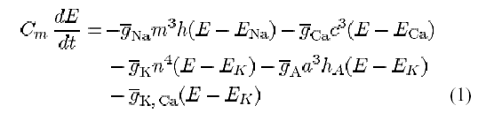
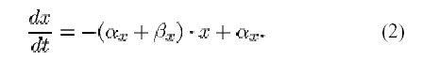

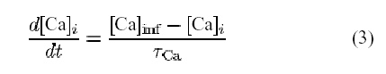

In order to apply a voltage to the neuron, two types of sources were used across all models: a monopolar point source and a disk electrode source. In both cases the pulse was administered to the neuron at a height of 30μm for 100μs. Each of the three membrane mechanisms were simulated with both sources.

Simulations using computational packages
Three mathematical models were examined in the simulation of the retinal ganglion cell. To gain a better understanding of these models, the Linear Passive (LP) model, Hodgekin-Huxley (HH) model, and Fohlmeister-Coleman-Miller (FCM) model, simulations were conducted using the mathematical modeling packages NEURON and XPPAuto. Compartmental modeling was studied in NEURON, and single-compartment models were researched and implemented in XPP. Correlations found between model implementations and prior work in XPP allow for better understanding of the author’s three proposed models.
The LP model is a passive, linear implementation. Linear implies that given two input signals x1(t) and x2(t) which produce corresponding outputs y1(t) and y2(t), respectively, then for any constants a and b, ax1(t) + ax2(t) = ay1(t) + ay2(t). Note that many operations such as integrals and derivatives are linear, also implying linearity in the expression dVc/dt from a parallel RC circuit. A passive circuit element is one that does not contribute energy to the circuit. Thus, the LP model consists of a series of identical compartments without time-varying rate constants, implying that conductance values are held constant. In addition, fast computation is allowed by modeling every compartment in the cell with identical parameters. This model is easiest to implement because all compartments of the neuron are modeled identically and only affect each other through serial resistors.
The researchers used the computational package NEURON to analyze three-dimensional neuron data and to model each compartment with unique parameters. The HH model was provided with NEURON, and researchers used an active model (circuits with elements that contribute energy) to represent the neuron’s axon and soma and a passive model to analyze its dendrites. A simplified compartmental model was studied to understand the author’s ability to utilize NEURON’s compartment capabilities and to study the better accuracy such a model yields. When the myelinated HH axon was preferentially stimulated by a constant current stimulus, no action potential was produced due to the axon’s insulation (myelin). However, when the neuron’s soma was preferentially stimulated, an action potential at the axon hillock was produced due to the soma’s proximity to the point of lowest propagation threshold. This was emphasized when a small depolarization was produced if the cell was stimulated at a dendrite close to the axon hillock. By exploring this model in NEURON, it was shown that compartmentalization adds realism to traditional mathematical models by adding a spatial/proximity component to traditional HH computational methods. The researchers used 3-D data imaging techniques to scan a neuron model into NEURON then split it into about 9000 compartments, each separated with less than a one percent change in membrane potential. From the aforementioned NEURON experiments, this technique clearly allows for more biologically realistic simulation, dispelling errors inherent in point-based modeling.
The FCM model was the most biologically realistic and most mathematically complex of the attempted models. In an attempt to parallel this model with earlier presented models in computational neuroscience, the model was implemented in XPP (Appendix A). Many similarities existed between this model and prior ones. Examining the differential equations, dE/dt (electrical potential) is a familiar expression of a parallel RC circuit. However, the FCM model incorporates five ion channels in contrast to Hodgekin and Huxley’s three channel approximation (Na⁺, K⁺, and leak). The second differential equation, dCai/dt (internal calcium concentration), is also worth noting. Note that the Endoplasmic Reticulum Calcium stores were not taken into account, only being approximated by modeling a single influx and efflux of Calcium. The remaining six differential equations, the kinetic equations, each represent the influx/efflux rate constants of passage through each ion channel. Note in dE/dt that each rate conductance is signified as some proportion of a maximum rate constant (“g bar”), a value proportional to some combination of the antiderivative of each kinetic equation, a result consistent with other models.
The steady-state equations also reveal properties of the model. Each ion channel is a function of electrical potential (E) with the exception of Calcium-gated Potassium channels, which have a rate constant proportional to the internal Calcium ion concentration. Also note that this model is dependent on an applied current (I_{stim}).
After compiling the XPP file, a dampened harmonic oscillator was reproduced at I_{stim} = 40 pA, a value inconsistent with the undampened oscillator in the FCM paper. This inconsistency can be explained because plausible initial conditions were not given (and in fact were mostly borrowed from the Hodgekin and Huxley model). Second, several constants were not given and again had to be inferred. Third, necessary units for proper simulation were vague and could have been displaced by several factors for some parameters. Nevertheless, the investigation of the three models the authors applied was of immense aid in understanding each model’s individual shortcomings and utility.

Purpose of Experiment
The purpose of the simulations in this paper is to determine what is easier stimulated by an electrode: ganglion cells directly below the electrode or fibers passing proximally from distant ganglion cells such as axons or dendrites.
When ganglion cell axons are preferentially stimulated, a visual implant may produce images composed of wedges as axons from multiple cells are stimulated. A wedge is perceived because of the way the axons travel along the retina. Axons originate at their ganglion cell and travel along the retina to converge at the optic nerve. Stimulation close to the optic nerve would make the brain perceive stimulation of all ganglion cells projected out from that point, making the image resemble a wedge (Greenberg et al. 1999).
If ganglion cell dendrites were preferentially stimulated, then electrodes would produce large circular shapes because dendrites from several neighboring cells would be stimulated (Greenberg et al. 1999).
The best case is if cell somas are preferentially stimulated. This way specific ganglion cells can be activated, producing the best possible resolution of a visual implant (Greenberg et al. 1999).

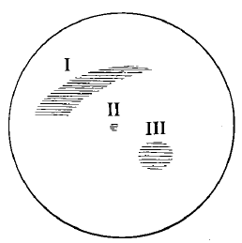
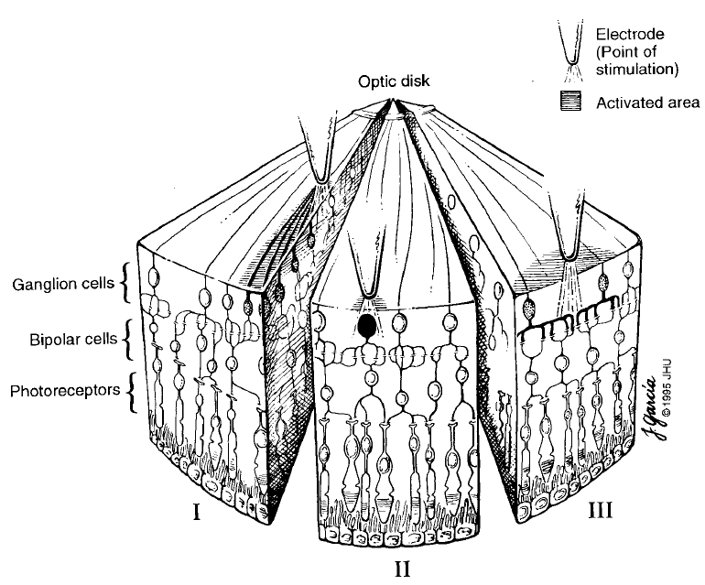
Part I of Figure 4 shows the wedge shape expected if the axons are preferentially stimulated. Part I of Figure 5 shows the effect on the ganglion cells and their axons if the axons are preferentially stimulated. Parts II and III show the effect if the soma and dendrites, respectively, are preferentially stimulated (Greenberg et al. 1999).
Figure 4: Perceived images
Picture from Greenberg et al.
Figure 5: Retina showing ganglion cells in relation to other cells and how the electrodes could affect various parts of the ganglion cells.
Picture from Greenberg et al.

Results
Passive model:
Over the soma does not have the lowest threshold (not easiest to depolarize, easiest to stimulate an action potential). It is slightly easier to depolarize the axon to the traditional 15 mV membrane potential because the smaller structures have higher input resistances which highly influence this model. This model is not very realistic, and it is only included for comparison to the other models (Greenberg et al. 1999).

Moving electrode models
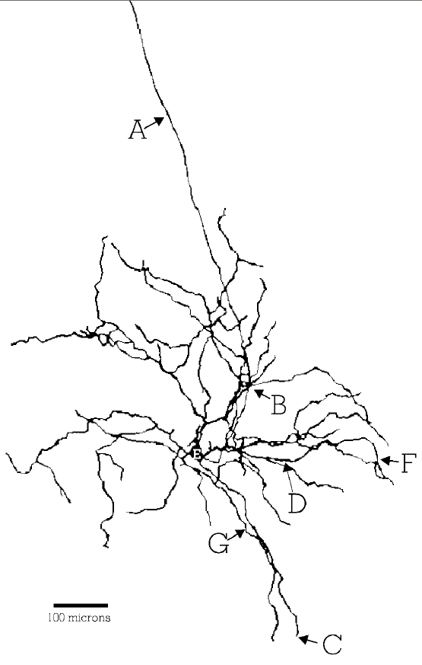
In the moving electrode models, the electrode starts over point E (the soma) and moves out toward the other points. The threshold is different at these points, and this difference was recorded and analyzed.
Figure 6: Diagram of the ganglion cell used in the models along with reference points where electrodes were placed.
Picture from Greenberg et al.

Effect of varying electrode position in the Hodgkin-Huxley Active Model
The lowest threshold was found to be over the soma. As the electrode was moved away from the soma, action potentials grew rapidly if the electrode moved over dendrites (about 75 times the size of the threshold over the soma), but stayed constant within a factor of two if moved over the axon. The action potentials for this model occurred at the axon (Greenberg et al. 1999).

Effect of varying electrode position in the FCM Active Model
The general effect is very similar to that of the HH model, except the dendrites have much lower thresholds. The dendrites also fire off action potentials when stimulated (not just the axon). These travel to the soma, and if multiple dendrites fire action potentials, then these sum together at the soma causing the soma itself to fire an action potential which propagates down the axon, sometimes stimulating the dendrites again. Points C and G did this most effectively, while the other points either had the action potential die off at the soma, or the action potential in the axon was caused by the electrode being close enough to the axon to stimulate the axon itself (Greenberg et al. 1999).

Effect of replacing point source electrodes with disc electrodes
Previous results were with point electrodes, which can only exist in a simulation. Disc electrodes can actually be made with current technology; hence a prosthesis would be made of disc electrodes. With 50 micrometer diameter discs and the HH model, the cathodic threshold was 1.2 times higher over the axon than over the soma. Clinical trials referenced by the authors used 100 micrometer diameter discs, and when those were simulated, the results were the same as for the 50 micrometer diameter discs (Greenberg et al. 1999).

Effect of varying soma size in the HH model
Primate somas are smaller than the 24 micrometer somas used in the experiment, so a simulation was performed with 10 micrometer somas and a point source electrode. The results are very similar to those with the larger soma, in that as the electrode moves over the dendrites then the thresholds rise, but when moved along the axon, then the threshold stays roughly the same. The only difference was that the axon was easier to stimulate compared to the soma (89.5% of the threshold, compared to 158% for the 24 micrometer soma) (Greenberg et al. 1999).

Conclusion
The part of the Retinal Ganglion Cell stimulated by an electrode determines the maximum resolution of a retinal prosthesis (Greenberg et al. 1999). According to the Hodgkin-Huxley simulations, electrodes preferentially stimulate the soma, meaning a 10 micrometer resolution should be possible because that is the size of the primate soma. If, however, the dendrites are not too difficult to stimulate, the charge from one electrode can affect neighboring cells resulting in a resolution of hundreds of micrometers, as suggested by the FCM model. Since the best clinical resolution achieved so far is around 500 micrometers, it is still not clear which model is closest to the truth (Greenberg et al. 1999).
The models used in this paper are very complex, especially when considering the number of compartments used. The computational packages greatly simplified the modeling process, resulting in insights that may not be possible using other techniques. Attempting to recreate the models on our own also greatly increased our understanding of how the models work.
It is also important to mention that this paper assumes that the Retinal Ganglion Cells are the ones that would be stimulated by an electrode on the retina. As figure 5 shows, there are other kinds of cells on the retina. While these are much farther away from the electrode, it is possible that those would be stimulated easier than the ganglion cells. This does not seem probable, so the authors assumed it would not happen.

Appendix A

# rgc.ode: XppAut file for modeling
# the repetitive firing of retinal
# ganglion cells (FCM model)

############################
# initial conditions
############################

init m=0.052,h=0.596,c=0,n=0.317
init A=0,hA=0,E=-70,Cai=50
init Cm=1

############################
# parameters
############################

param ENa=35,EK=-75,ECa=70
param bGNa=40,bGCa=2,bGK=12,bGA=36
param bGKCa=0.05
param j=2
param Cadiss=0.001,Cares=0.0001
param Istim=40,ICa=2

############################
# steady-state functions
############################

# Na+ channel
am(E)=(-0.6*(E+30))/(exp(-0.1*(E+30))-1)
bm(E)=20*exp(-(E+55)/18)
ah(E)=0.4*exp(-(E+50)/20)
bh(E)=6/(exp(-0.1*(E+20))+1)

# Ca2+ channel
ac(E)=(-0.3*(E+13))/(exp(-0.1*(E+13))-1)
bc(E)=10*exp(-(E+38)/18)

# K+ channel
an(E)=(-0.02*(E+40))/(exp(-0.1*(E+40))-1)
bn(E)=0.4*exp(-(E+50)/80)

# A channel
aA(E)=(-0.006*(E+90))/(exp(-0.1*(E+90))-1)
bA(E)=0.1*exp(-(E+30)/10)
ahA(E)=0.04*exp(-(E+70)/20)
bhA(E)=0.6/(exp(-0.1*(E+40))+1)

gKCa(Cai)=bGKCa*(((Cai/Cadiss)^j)/(1+(Cai/Cadiss)^j))

############################
# differential equations
############################

dCai/dt=-0.000015*ICa - (0.02)*(Cai-0.0001)
dE/dt=(-bGNa*(m^3)*h*(E-ENa)-bGCa*(c^3)*(E-ECa)-bGK*(n^4)*(E-EK)-bGA*(a^3)*hA*(E-EK)-gKCa(Cai)*(E-EK)+Istim)/Cm
dm/dt=-(am(E)+bm(E))*m+am(E)
dh/dt=-(ah(E)+bh(E))*h+ah(E)
dc/dt=-(ac(E)+bc(E))*c+ac(E)
dn/dt=-(an(E)+bn(E))*n+an(E)
dA/dt=-(aA(E)+bA(E))*A+aA(E)
dhA/dt=-(ahA(E)+bhA(E))*hA+ahA(E)

@ ylo=-100,yhi=100,xlo=0,xhi=50

done

References
Greenberg, R.J., Velte, T.J., Humayun, M.S., Scarlatis, G.N., and de Juan, Jr., E. A Computational Model of Electrical Stimulation on the Retinal Ganglion Cell. IEEE Trans. Biomed. Eng. 46: 505-514, 1999.

Roush, W. Envisioning an Artificial Retina [news]. Sci. 268: 637-638, 1995.

Fohlmeister, J.F., Coleman, P.A., and Miller, R.F. Modeling the Repetitive Firing of Retinal Ganglion Cells. Brain Res. 510: 343-345, 1990.

Fohlmeister, J.F., and Miller, R.F.Mechanisms by Which Cell Geometry Controls Repetitive impulse Firing in Retinal Ganglion Cells. J. Neurophysiol. 78: 1948-1964, 1997.

Humayun, M.S., de Juan, Jr., E., Dagnelie, G., Greenberg, R.J., Propst, R.H., and Phillips, D.H. Visual Perception Elicited by Electrical Stimulation of Retina in Blind Patients. Arch. Opthalmol. 114: 40-46, 1996.

