Lead Contamination of Groundwater in the Northeast of Buenos Aires Province, Argentina

JACQUELINE KÖHN
Conicet, Depto de Geofísica Aplicada, Facultad de Ciencias Astronómicas y Geofísicas, Universidad Nacional de La Plata, Argentina.
e-mail: jkohn@fcaglp.fcaglp.unlp.edu.ar

EDUARDO E. KRUSE
Conicet, Depto de Geofísica Aplicada, Facultad de Ciencias Astronómicas y Geofísicas, Universidad Nacional de La Plata, Argentina.
JUAN E. SANTOS
Conicet, Depto de Geofísica Aplicada, Facultad de Ciencias Astronómicas y Geofísicas, Universidad Nacional de La Plata, Argentina.

Abstract The progressive increment of the water needs due to the expansion of the urbanization and industrialization in different regions in the Northeast of the Province of Buenos Aires, Argentina has produced an intense development of the groundwater resource.
The main objective of this work consists of the study of two sectors of different hydrogeologic features that have been contaminated by lead from industrial activities. We employ a method of characteristics combined with a mixed finite element procedure to simulate the plume evolution in time.
The result of this investigation is the application of an efficient tool for handling the hydric resources and evaluating the environmental impact from the transport of contaminants in groundwater.
Key words lead contamination; groundwater; Northeast of Buenos Aires Province, Argentina; shallow aquifer; numeric simulation

INTRODUCTION

The detailed description of the migration of pollutants is fundamental for the groundwater monitoring and it represents the base for the preservation of this groundwater resource. An important problem is the increasing contamination of groundwater, which in turn, leads to a decrease in the availability of good quality water. Relvant to the study described heren, contamination dramatically affects the regional behavior of the shallow groundwater system located in the northeast of the Province of Buenos Aires, Argentina.
In this paper, we assess the variability in solute migration by augmenting historical data with groundwater sampling for water quality analyses and hydrogeological investigations. Recent reports reveal contamination of soil and groundwater with heavy metals, and in particular, show a high lead concentration that can be toxic to living organisms. Lead candamage human health, especially through disruption of the functions of the brain, kidneys, and reproductive system. The body accumulates lead in the blood, bones, and teeth, and soft tissue. Lead is absorbed through ingestion, inhalation, or other exposures.
There are many sources of lead in our environment including paint, gasoline, water distribution systems, food, and various hobby supplies. The lead is transported to the environment by atmospheric deposition, and solid and liquid waste disposal. Groundwater receives lead contamination by mobilization of lead either natural or enriched from anthropogenic activities in the soil and in some cases, mineral weathering. The Environmental Protection Agency (USEPA) current drinking water lead standard is 0.015 mg l⁻¹. The USEPA lead standard is used in Argentina as a tolerable limit for drinking water.
The transport of reactive solute in spatially variable soil systems, and in particular, the effect of the spatial variable hydraulic properties on the solute transport were studied by van der Zee et al (1987).
Marzal et al. (1995) presented a coupled transport-chemistry hydrogeochemical model, which can predictthe development of contamination plumes.
The linear isotherm model combined with a convective-dispersive solute transport model have been used frequently to describe the transport of material through porous media. Begovich & Jackson (1975) used a linear adsorption isotherm for lead. In the paper of Chen et al. (1992), adsorption of cadmium, copper, or lead in the presence or absence of the other two elements was studied at five concentration levels.
Adsorption of lead and other heavy metals by soils and the transport has been studied by many authors (e.g., Griffin & Au 1977; Farquhar et al. 1997).
In this paper, we describe two field experiments, whichwere conducted in the shallow groundwater system in Northeast of Buenos Aires Province, Argentina during 1999, to investigate the transport of lead contaminated water through the saturated zone..
Using hydrogeologic data from pumping tests, we constructed the hydraulic conductivity field, which was used in a numerical model to obtain the groundwater flow field. The flow field was used to simulate lead transport through the saturated zone. The hydraulic conductivity is affected by the heterogeneity of the aquifer.used The field hydraulic conductivity measurements were kriged to generate the spatial distribution of hydraulic conductivity .
The advection-diffusion equation was used to describe the spatially variable vertical lead transport using a mixed finite element model, which provides an efficient way to eliminate spurious numerical oscillations and handle the convective term in the equation.

MODEL

Hydrogeological characteristics of the areas study

The shallow groundwater system includes the Puelche, Pampeano, and Postpampeano hydrogeologic units..
The Pampeano unit is located in high plains and the Postpampeano unit is in low plains. Each unit includes the water table, and the associated groundwater is directly affected by processes originating in the surface (infiltration and contamination). Each unit overlies the Puelche unit, which is the main aquifer of the northeast Buenos Aires province. In the study area, the Puelche unit is located at a depth of about 40 m with thickness up to 20 m and it is composed by fine to medium sand.
The Pampeano unit is composed of silty sediments, in part clayey and sandy with calcareous materials. The unit is locally anisotropic, which affects production and associated abstraction rates. it’s the Pampeano unit is about 40 m thick having a regional transmissivity of 100 m² day⁻¹. The Postpampeano unit is composed of silty clay, clay, and clayey silt and varies in thickness from 3 to 7 m with a hydraulic conductivity of 0.01 m day⁻¹. The shallow groundwater systems (Puelche, Pampeano, and Postpampeano) are hydraulically connected and constitute a “multilayer aquifer”.
The grounddwater lead concentration in non contaminated areas in the region are about 0.003 mg l⁻¹ of the Pampeano and Postpampeano units (Galindo et al. 1999). The highest lead concentrations (0,10 mg-l⁻¹) were in shallow groundwater of industrial areas. For this study, two field sites in these industrial areas were chosen to simulate the evolution of plume of lead contamination, one in the Pampeano unit and the other in Postpampeano unit.

Solute transport equations

The transport equation for lead was dervied from the law of conservation of mass applied to a differential volume element in the porous medium. The accumulation of the contaminant is exclusively caused by the convective-dispersive transport and can be written as:
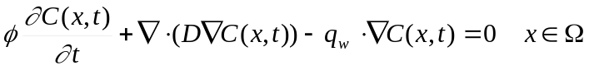 (1)

(Please check equation error) where C(x,t) denote the mass concentration of the contaminant at x location, q_{w} the flux velocity vector, Ω the two-dimensional porous domain, ø the porosity and D the dispersion tensor. To fully define the system mathematically, initial and boundary conditions must be specified. The initial condition is defined by specifying the total concentrations of the solute at time zero throughout the transport domain. The flow satisfies the Darcy’s law and under the incompressibility assumption, we have that
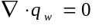 (2)
The modeling technique is based on a discrete representation of the porous medium. The stationary velocity field is computed using a hybridized mixed finite method and small variations in groundwater flow directions were found.
The transport equation is solved numerically by combining a method of characteristics with a mixed finite element procedure, (Douglas et al. 1982; Douglas et al. 1994), which is used to eliminate the nonsymmetry in the operators due to advection.

Lead Adsorption

The heterogeneous characteristic of the porous medium and the sorption in soil influence the solute transport. When chemical species are dissolved in groundwater they may adsorb on the surface of porous media, which can be modelled by either linear or nonlinear isotherms. The simplest and most widely used of the equilibrium sorption isotherms is a linear isotherm. That is, it is assumed that the amount of the solute adsorbed by the soil matrix and the concentration of the solute in the soil solution are related linearly. Taking adsorption into account, the mass balance equation becomes
(3)
In equation (3) ρ denotes the bulk density of the soil and S is the adsorbed concentration. In this study we consider a linear adsorption isotherm of the form
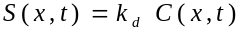 | (4)
where k_{d} is an empirical distribution coefficient and it is a measure of retention of solute by the soil matrix.

RESULTS

Aplication examples

The model used to simulate lead transport in two hydrogeological different settings: the Pampeano and Postpampeano units. In each unit, however, lead concentrations greater than 0.05 mg l⁻¹ have been recorded for water sampled from wells, indicating the existence of contamination. We analyzed the lead concentration variations in two 10 x 5 m sections of the saturated zone for each unit. The initial condition for the lead contamination was C₀=0.05 mgl⁻¹ at the top of each section (depth z=0 m) located at x=3 m in the horizontal direction. In all the simulations the following parameters were use: ∆x=1 m, ∆z=0.25 m, ∆t=1 day, k_{d}=0.2536 mmolkg⁻¹ (Houng & Lee 1998) and the calculations were obtained for a 5-m depth of a saturated soil profile. For the Pampeano unit, the hydraulic conductivity ranged from 1 to 10 m day⁻¹ with a porosity (φ) = 0.2, and for the Pospampeano unit, the hydraulic conductivity ranged from 0.01 to 0.1 m day⁻¹ with φ = 0.4.
In the first case, the concentration maximum migrates at 1 m horizontally from the contaminated point after 30 days (Fig. 1), and the maximum concentration continues to move at the top of the saturated zone. After 60 days. the concentration maximum also moves vertically 0.25 m below the initial depth of contamination (Fig. 2). The temporal concentration profile development under the initial point of contamination is shown as a function of the depth in Fig. 3.
In the medium of lower hydraulic conductivity, the Postpameano unit, the lead doesn't migrate appreciably, mainly due to the low groundwater velocity (Fig. 4). After 400 days, lead doesn't move more than 1 m (Fig. 5).

CONCLUSIONS

Model simulation of groundwater lead migration demonstrate that the hydraulic conductivity and porosity are important controls in the shallow groundwater system of the northeast of the Province of Buenos Aires, Argentina. The migration of lead in the Postpampeano unit is very slow and the movement is minimal. The possibility that significant amounts of lead would reach the main aquifer (Puelche), which underlies the Postpameano unit, would only occur along macropore features like fractures or spatial heterogeneity of hydraulic conductivy, such as fine lenses of sand.
The migration of lead in the Pampeano unit is slow, but mobility is higher than in the Postpampeano unit and may in time the potable groundwater supplies in the region.
The examples presented here illustrate that solute transport can bepredicted for different hydrogeologic conditions and the predicted transport may be used to plan different remediationstrategies.

REFERENCES
Begovich, C. L. & D. R. Jackson (1975): Documentation and application of SCEHM- A model for soil chemical exchange of heavy metal. Report ORNL/NSF/EATC-16. Oak Ridge Natl. Lab., Oak Rigde, Tenn.
Chen, C. T., D. Y. Lee, & K. H. Houng (1992): Competitive adsorption of Cd, Cu and Pb by acid soils. J. Chin Agric. Chem. Soc. 30, 83-89.
Douglas J, Russel T.F. (1982): Numerical methods for convection-dominated diffusion problems based on combining the method of characteristics with finite element or finite differences procedures, SIAM J. Numer. Anal. 19, 871-885.
Douglas, J. Jr., F. Pereira, L. M. Yeh & P. J. Paes Leme (1995): Domain decomposition for immiscible displacement in single porosity systems, in: Finite Element Methods: Fifty years of the Courant Element, Eds. M. Krizek, P. Neitaanmaki and R. Stemberg, Lecture Notes in Pure and Applied Mathematics 164, Marcel Dekker, New York, 191-199.
Farquhar, M. L., Vaughan D. J., Hughes C. R., Charnock J. M. & K. E. R. England (1997): Experimental studies of the interaction of aqueous metal cations with mineral substrates: Lead, cadmiun, and copper with perthitic feldspar, muscovite and biotite. Geochimica et Cosmochimica Acta 61 (15), 3051-3064.
Galindo G, M. A. Herrero, M. Flores & T. Fernandez (1999): Correlación de metales trazas en aguas subterráneas someras en la cuenca del Río Salado, Provincia de Buenos Aires, Argentina, Serie Correlación Geológica, Universidad nacional de Tucumán, Vol 13, 251-262.
Griffin R. A. & A. K. Au (1977): Lead Adsorption by Montmorillonite using a competitive Langmuir equation, Soil Sci. Soc. Am. J. 41, 880-882.
Houng K. H. & D. Y. Lee (1998): Comparisons of linear and nonlinear langmuir and Freundlich curve-fit in the study of Cu, Cd and Pb adsorption on taiwan soils, J. Soil Sci., 163 (2), 115-121.
Marzal P., A. Seco, J. Ferrer & C. Gabaldón (1994): Modeling multiple reactive solute transport with adsorption under equilibrium and nonequilibrium condictions, Adv. Water Resour. 17, 363-374.
Van der Zee S. E. A. T. M. & W. H. van Riemsdijk (1987): Transport of Reactive Solute in Spatially Variable Soil Systems, Wat. Resour. Res. 23 (11), 2059-2069.

FIGURE CAPTIONS

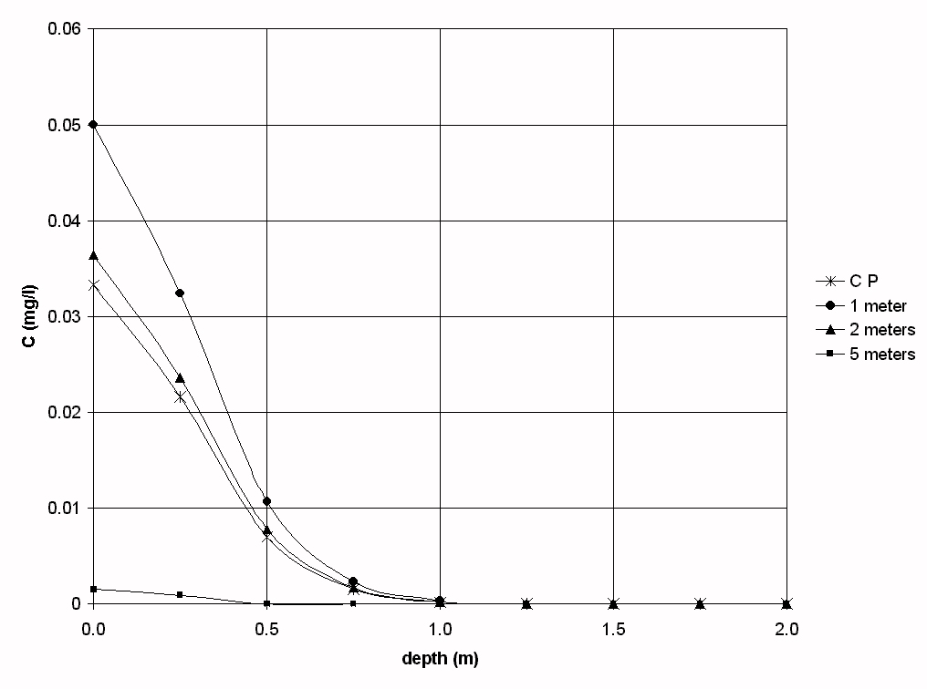
Fig. 1 Lead concentration profile at time t=30 days at several distances from the point of contamination (C.P.) in the Pampeano unit.
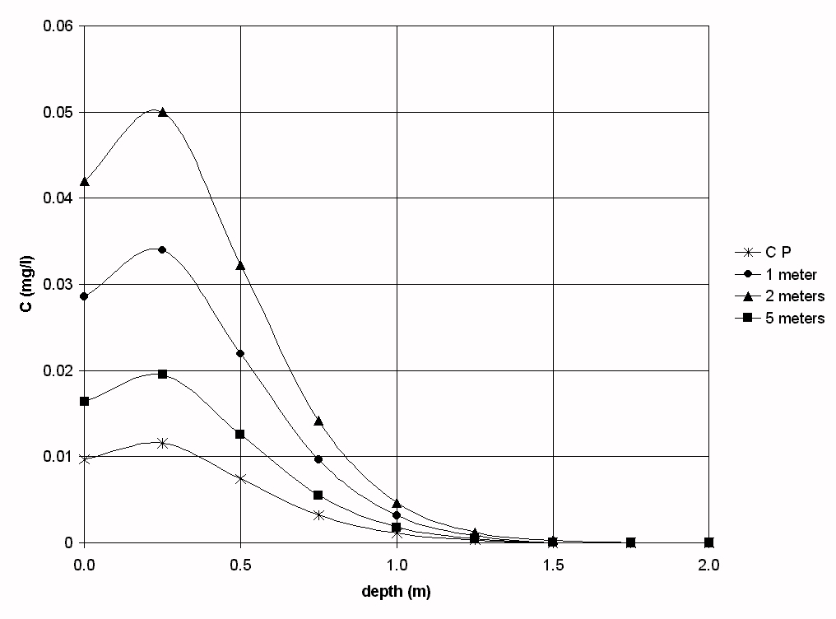
Fig. 2 Lead concentration profile at time t=60 days at several distances from the point of contamination (C.P.) in the Pampeano unit.

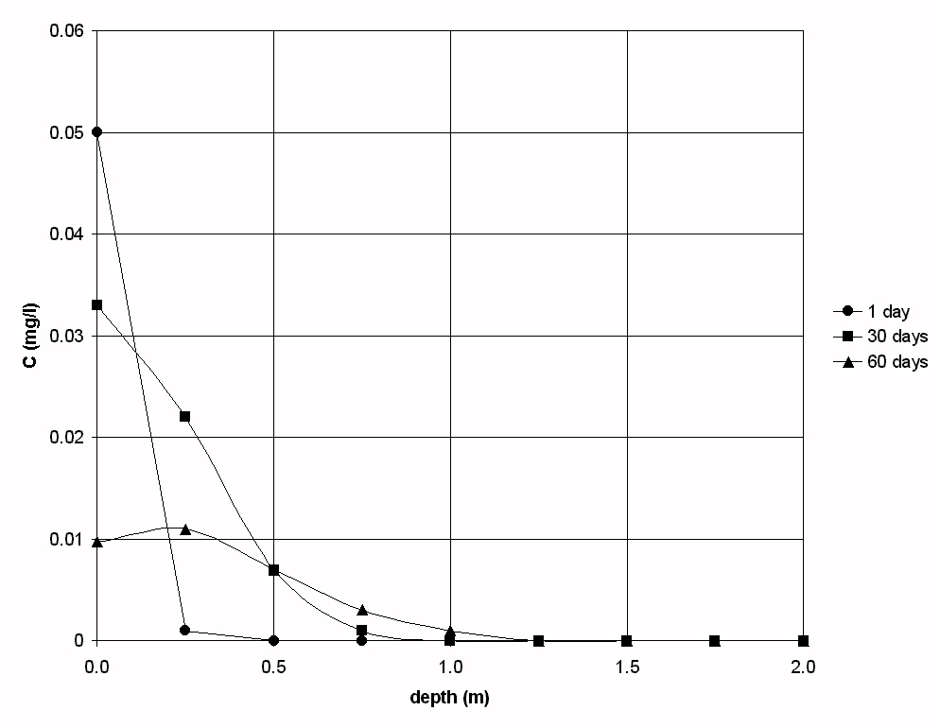
Fig. 3 Lead concentration profile at various times at the contaminated point for the Pampeano unit.
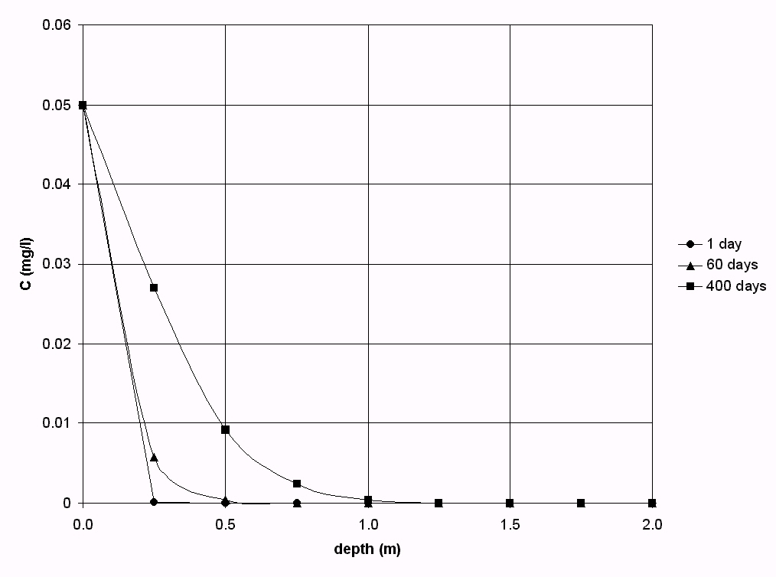
Fig. 4 Lead concentration profile at various times at the contaminated point for the Postpampeano unit.
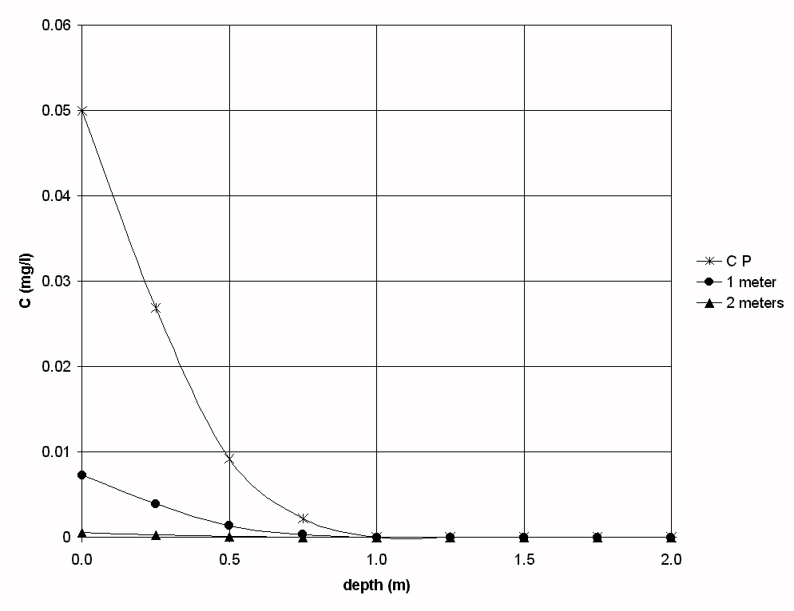
Fig. 5 Lead concentration profile at time t=400 days at two distances from the point of contamination (C.P.) in the Postpampeano unit.

