Free tutoring is available for math, science, and engineering 100 and 200 level courses.
Tutoring is provided by outstanding students in Science and Engineering.
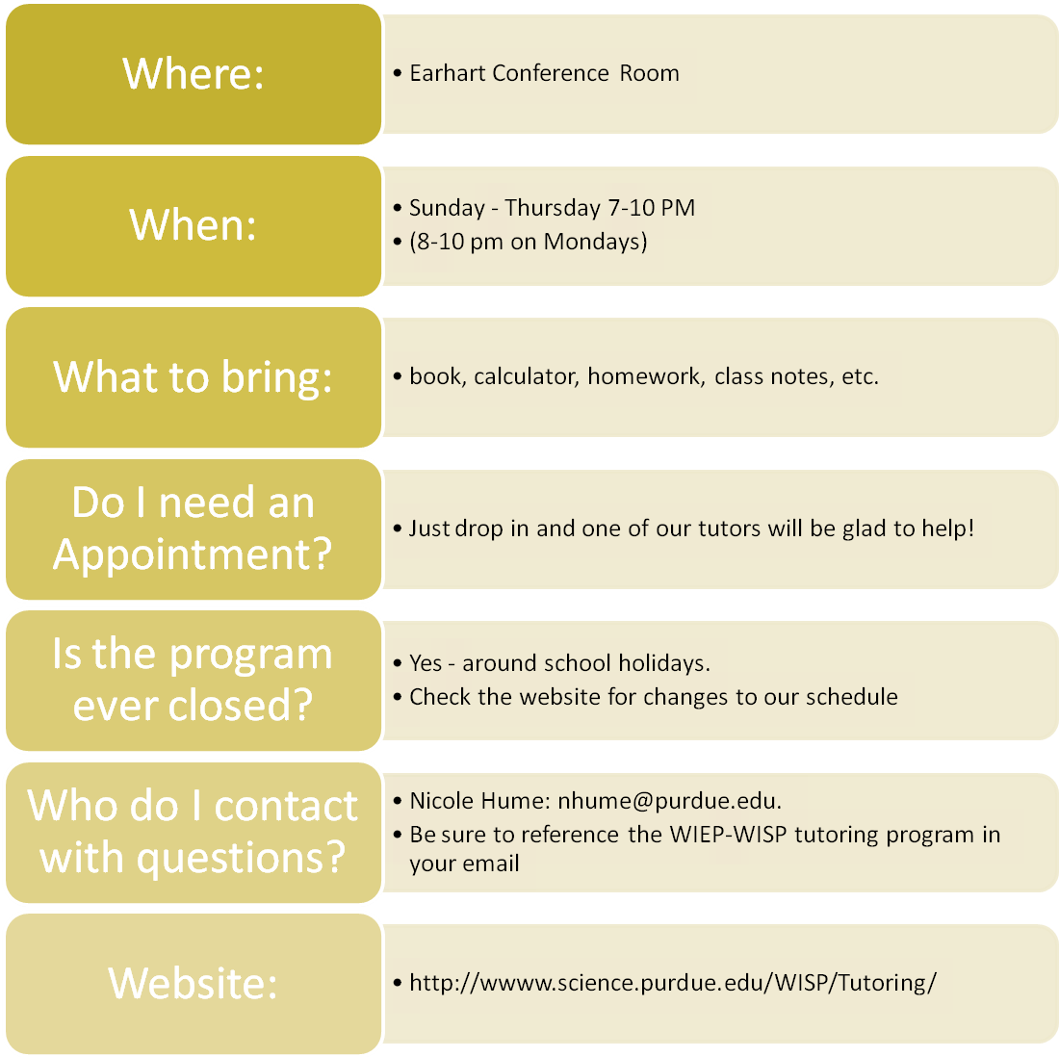
Tutoring Sponsored by the Women in Engineering and Women in Science Programs

