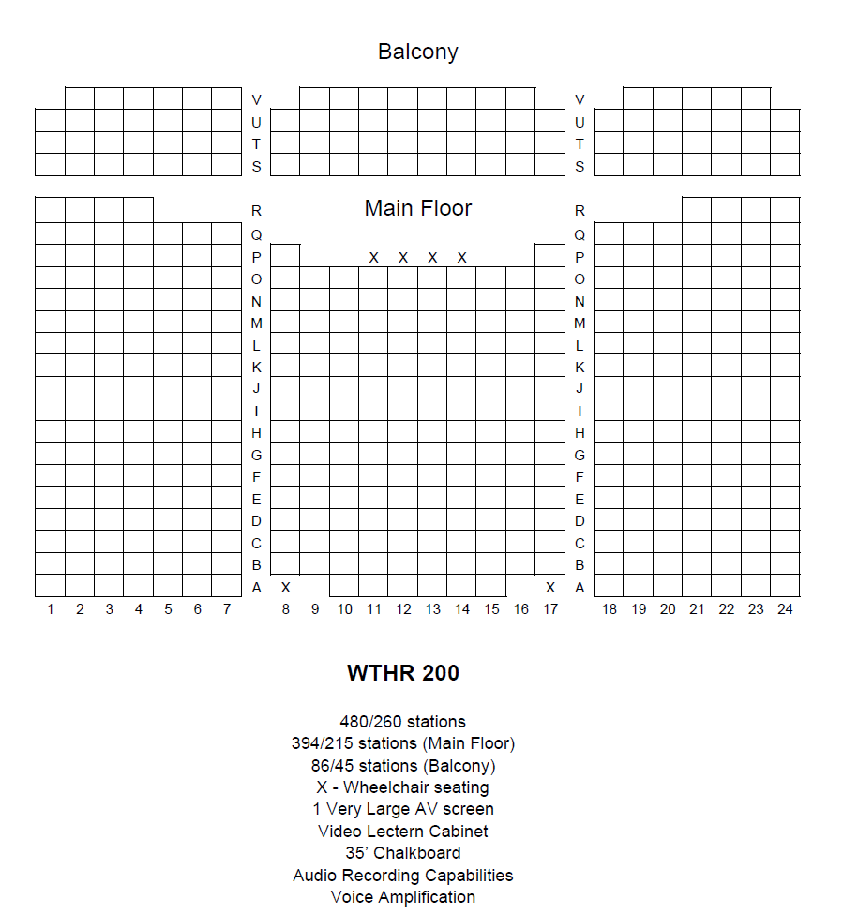

**Zachary Letterhos**

**Emma Reid**

**Alex Porter**