Undergraduate Research Project

Project Name: | 2026 US Election Forecasting at Purdue | Number of Positions: | 2
Supervisor: | Prof. Alexandria Volkening
Supervisor e-mail: | avolkening@purdue.edu
Project Description: | Election forecasting involves polling likely voters, weighting polling data, combining it with other information (e.g., how the economy is doing), and accounting for uncertainty. In the project, we will use publicly-available polling data, together with mathematical modeling, to produce forecasts of the 2026 US senatorial and gubernatorial elections. For more information, see my group’s 2024 forecasting website here: https://c-r-u-d.gitlab.io/2024/
Final Deliverables: | We will produce forecasts of the 2026 US elections and post our forecasts on our website. We will write code for handling polling data and weighting it in new ways.
Weekly Working Hours | - Average of 9 hours per week during the semester  - Potential for full time during the summer
For Credits/Voluntary | For credit during the academic year: 3 credits per semester  For funding during the summer
Desired Qualifications | I am looking for driven students who are excited about interdisciplinary research and collaboration, have background in linear algebra and differential equations, have strong programming skills (especially Matlab; R, Html, or Javascript are also helpful), and are interested in remaining on the election team for two semesters (until Dec. 2026).
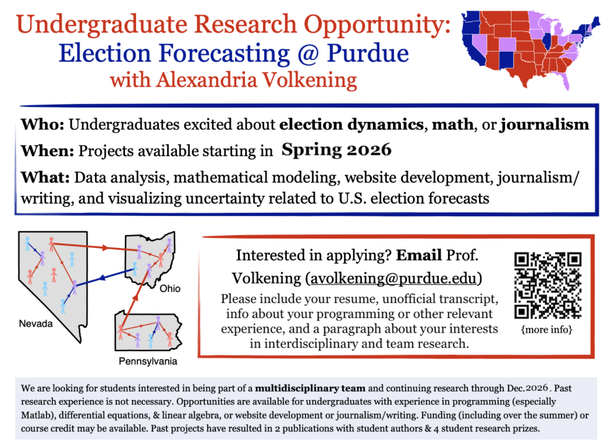

If you are interested in participating in this research project, please send an e-mail to the supervisor e-mail listed above together with a resume, a list of what courses you’ve taken or a copy of your transcript, and a personal statement explaining why you are interested in this project.

