Alternative practices for online teaching in Spring 2020

See Default practices for online teaching in Spring 2020
for default practices.

Note that if you stream live, you should record and provide a way for students to view and interact with you asynchronously, preferably also a low-bandwidth method, such as downloading notes.

Important points
- Any technological method can fail, so
  - Verify anything like an online exam by doing a dry run with something that doesn't matter at all - i.e., a single trivial question and a minimal number of completion points for submitting.
  - Build in redundancy to the extent possible - e.g., have your notes scanned and uploaded as described below to augment your lectures.

- It is not sufficient to have an unrecorded live stream of your class or to schedule exams or interactions with you at a single time.
  - You need to provide students a way of accessing recordings if you stream.
  - You need to provide a window of time for exams or other assignments.
  - You need to provide asynchronous ways of interacting - e.g., an online forum.

Feedback from students:
Please check in with your students by email or some other means to ask about what's going well and what the obstacles are for them. We might not be able to solve every problem, but we can try to address some. Please share with buzzard@purdue.edu

Access to course materials:
Some students in China have been having trouble accessing online homework and/or videos. One approach is for them to log in remotely as follows:

- go to https://goremote.itap.purdue.edu/
- log in with your Purdue Career account (not Boilerkey)
- choose the option to work in your browser.

This will bring up a remote desktop - you can start a browser and access Blackboard/MyLab there.

Videos have been slow to process and sometimes slow to stream on Boilercast/Mediaspace. It's important to have uploaded notes for those who can't get the videos. It's also possible to record audio only on Kaltura capture - this would have much lower bandwidth requirements.

iPad screen recording:
Here is a short video that describes screen recording on an iPad:
https://www.youtube.com/watch?v=_SKndqCYSx0

It’s helpful to have a note-taking app like Notability; there are many others, some paid, some free. Some of these apps require an active pen (e.g., Apple Pencil), while others can use your finger or a passive stylus. The department has a supply of pens with a soft tip that serves as a passive stylus. These are available in the main office. You might want to wear a glove as you write to avoid having your hand write on the screen.

You can upload the video to Kaltura Media Space by following the instructions outlined below. You can also upload directly to YouTube from Photos.
The video compression software at handbrake.fr is useful for reducing file size.

Here are some detailed notes from Arshak about using the iPad for recording:
Detailed notes on iPad recording from Arshak

OneNote is a Microsoft product available on the iPad and other platforms. You can log in with your Purdue career account. Here is a document that shows how to link with your courses:

https://drive.google.com/open?id=1IUUJqqMhv3CmHP924H9O_3A2A-yztYts

An app called Vittle: Smart Whiteboard Video (for ipad) is currently (as of 3/25) free in the App Store. It can record voice and writing and save as a video which can then be uploaded to Media Space. Here is the link:

https://apps.apple.com/us/app/vittle-smart-whiteboard-video/id1231173677

Kaltura (lecture capture):

Kaltura is essentially the same as Boilercast, except that you can do lecture capture from your computer or iPad. The recorded videos go to your “MediaSpace” account: https://mediaspace.itap.purdue.edu/my-media

When you find your video there (it will be on the top of the list), you can click on the link to it. There, you can select to share it and you’ll get a big long URL that you can copy to post to your web page.

Recording a Kaltura lecture on your personal computer/tablet:
https://www.cs.purdue.edu/teaching-remotely/kaltura.html#3

Recording a Kaltura lecture with the camera on your ipad or phone:
https://mediaspace.itap.purdue.edu/
“+” (ADD NEW)
“Media Upload”
Login
“+ Choose a file to upload”
Take Video

Recording a screen capture video on your ipad and then upload to Kaltura:
On iPad, go to Settings, Control Center, and tap Customize Controls. Then tap the “+” symbol next to Screen Recording. To start a recording, swipe from the upper right corner toward the center of the screen and look for the recording symbol (looks like a circle with a dot in the middle,should be near the bottom). Tap and hold and tap the microphone to turn it on or off (to record with or without sound). (Leave the check mark on Photos--the iPad pieces together a bunch of photos to make a video.) Then tap Start Recording to start the recording. To stop the recording, swipe from the upper right corner and tap the recording symbol again. The video is stored in Photos on your iPad.

Here is a short video that describes screen recording on an iPad:
https://www.youtube.com/watch?v=_SKndqCYSx0

You can upload the video to Kaltura Media Space by following the instructions outlined above this one. You can also upload directly to YouTube from Photos or transfer to a Mac using AirDrop or with a cord to connect.

Unscheduled classroom capture - from Steve Bell:
I verified with Chris Creighton yesterday that you can go into an empty classroom in REC or UNIV and login and click on the little green rectangle in the lower right on the tray to start a capture. When you stop the capture, the video of the screen with your voice audio gets processed and after some minutes or hours appears in your MyMedia in kaltura. The recorded videos go to your “MediaSpace” account: https://mediaspace.itap.purdue.edu/my-media

When you find your video there (it will be on the top of the list), you can click on the link to it. There, you can select to share it and you’ll get a big long URL that you can copy to post to your web page. You can see how mine turn out — see Lecture 25 at the bottom of the list at

Remains of Bell's MA 530 lectures

WebEx:
Note that some people have found zoom to be more stable/easier to use. See below for info on zoom.

Basic setup of WebEx:
https://mediaspace.itap.purdue.edu/media/WebEx+basic+setup/1_5surkip0

How to share things on the presenter's screen:
https://mediaspace.itap.purdue.edu/media/Sharing+things+on+the+screen/0_58n2w2l8

How to record the meeting and find the recording:
https://mediaspace.itap.purdue.edu/media/Recording+and+sharing+a+WebEx+meeting/1_4vvkaqab

This is a video that Doug Crabill created for Stats that explains the process using recorded webex:

https://mediaspace.itap.purdue.edu/media/Using+WebEx+for+remote+office+hours+and+to+record+lectures+for+remote+viewing+%28edited%29/1_wiwkeoy9

WebEx capture with an iPad - from Donu Arapura:

1. Plug an iPad into the usb port of a Mac. (Steve points out that this step could be bypassed by using the Webex app on the iPad. I haven’t tried this yet. )
2. Start a note taking app on the iPad (I use goodnotes).
3. Start Webex on your Mac by, for example, using this link https://www.purdue.edu/innovativelearning/supporting-instruction/instructional-technology/webex.aspx
and then using the link labelled “Go to Webex”. You will need to log in with your Boilerkey at some point in this process.
4. Once you’ve successfully logged on, you will see a link labelled “Start meeting”, click on it. If this is the first time you are doing this, then you may need to download an extension for your web browser, and repeat steps.
5. Now you should have started a Webex meeting. Use the following settings: Audio on, Video off, Input from iPad.
6. You should see “Waiting for other users to join”. Ignore it. Set record, and start lecturing.
7. When you are done stop recording, and end meeting.
8. The system will start building a video. This will take several minutes, or longer. You can access it for example via this link

https://mediaspace.itap.purdue.edu

9. The remaining step is the same as in Steve’s email. Once you’re satisfied with video, “publish it”, and copy the link to your class web page.

Here is the link of for my testing page, in case you want to see how it looks

https://www.math.purdue.edu/~arapura/testing.html

The video isn’t a full lecture, just a 15 minute demo.

Zoom
Just sign up at Zoom’s front page (zoom.us) using your purdue.edu address. Don’t go to the special announcement page. That will bring you to a K-12 page. Once you sign up you will see that they have lifted the 40min time limit. Also, don’t link zoom with your google account. Otherwise it will always login with your gmail.

The note below from Xiangxiong Zhang includes ideas about using Zoom.

Other resources:
Visit bit.ly/rtresourcelist to view a crowd-sourced list of resources to support remote teaching that includes links to many institutional websites dedicated to the topic.

Network of STEM Education Centers (NSEC) has compiled a list of disciplinary resources on teaching remotely.

Gradescope - exams and grading:
Charlie Bouman and Greg Buzzard made a video about how to give an exam using Gradescope. It doesn't solve the proctoring problem, but it does have some nice features. It's available at

https://youtu.be/He0SAJRBTsE

A comment below this video has links to various sections of the video. Here are some instructions from Jim McClure to give to students if you use this method:

For each problem you will need to upload your answer. This can be either a pdf or an image (jpeg, png or other standard format). Gradescope does not accept Word files or .heic files. To upload a file, click "select file(s)", choose the file you want, and then "submit answer".

If you need to upload a second image, click "select file(s)" again, choose the file you want, and then "submit answer". When you're done with the problem, be sure to click "View your submission."

Then go to the next problem. If you want to go back to a problem and change your answer click "Resubmit" in the bottom right corner.

Matlab access:
For students who need access to Matlab for coursework, it's possible to do that remotely. Here is a link with some instructions:

https://engineering.purdue.edu/ECN/Support/KB/Docs/UsingITaPGoRemotesof

Two items:

1. Please be aware that there may be difficulties with this method - students may have trouble getting set up, and the response time may be slow depending on their internet connection and location.

2. Please have your students complete a very simple proof-of-concept assignment (something trivial that just shows they can complete the steps) before requiring an actual assignment.

Alternatives to Matlab (from David Umulis, BME):
I’ve been steering away from Matlab recently and into python. For python, it’s been working very well for “largish” classes to use Google colaboratory. Some may be useful for math- ODE and PDE solvers that are based on difference methods. Some nonlinear analysis using nonlinear solvers’ etc. I’m attaching one here: I have about 15-20 made up so far. Please take a look:

https://colab.research.google.com/drive/1It2QBedG13czsM_gDHcw_LFrJKSYOlVH

Exams on Pearson MyLab:
Antonio has created a video describing how to create online exams in Pearson MyLab:

https://youtu.be/Jtn9bO546ks

If you click on “Show More” in the description below the video, you will see timing indicators for the beginnings of various topics in the video.

If you want a student account so you can take the test as a student, please send email to Kathryn Lutterschmidt at kathryn.lutterschmidt@pearson.com Please send her the id number of the course which you want to access as a student and your Purdue email, if you use another email address to write to her. Explain to her what you want to do. She is very familiar with our operation. She usually responds very quickly, but I am not sure how busy she is with all this.

Before going live with an actual exam, prepare a trial test, perhaps as a short quiz. The idea is the same as what is explained in the video, except you pick ``create a quiz'' instead of a ``create a test'' from the menu. You do not have to make any adjustments to the gradebook.

Once you create the exam, you may want to see it from the student point of view. Here is a video showing how to do it. You should do this from your toy course. https://www.loom.com/share/8c4678c311a6443790796d43c5db32ba
Adding Custom-made problems to Exams (MyLab)

(This will require Adobe Flash Player and you need to allow the page to use Flash.)

You can add a custom problem and add those to create on your exam using the method above.
On “Assignments”, using the manage mode, you can click on “More Tools>Manage Custom Questions”.

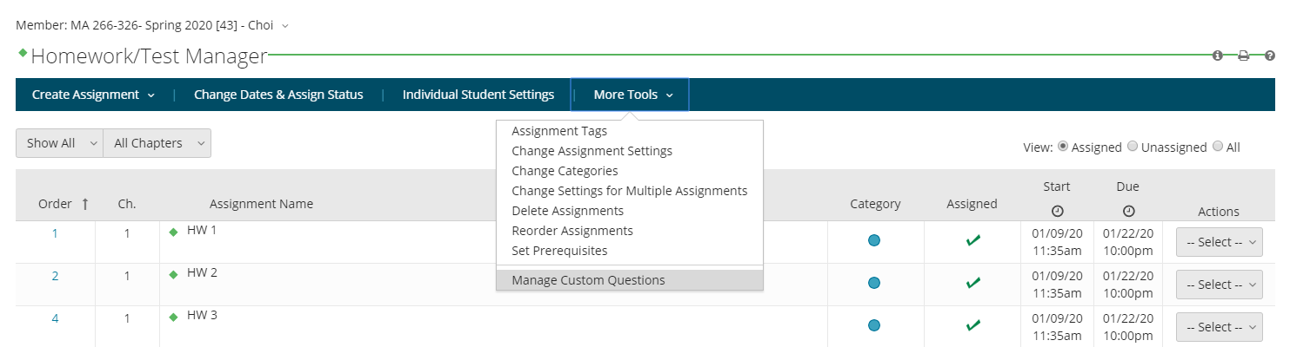

Assuming you have Flash available, you will see the screen like this below.
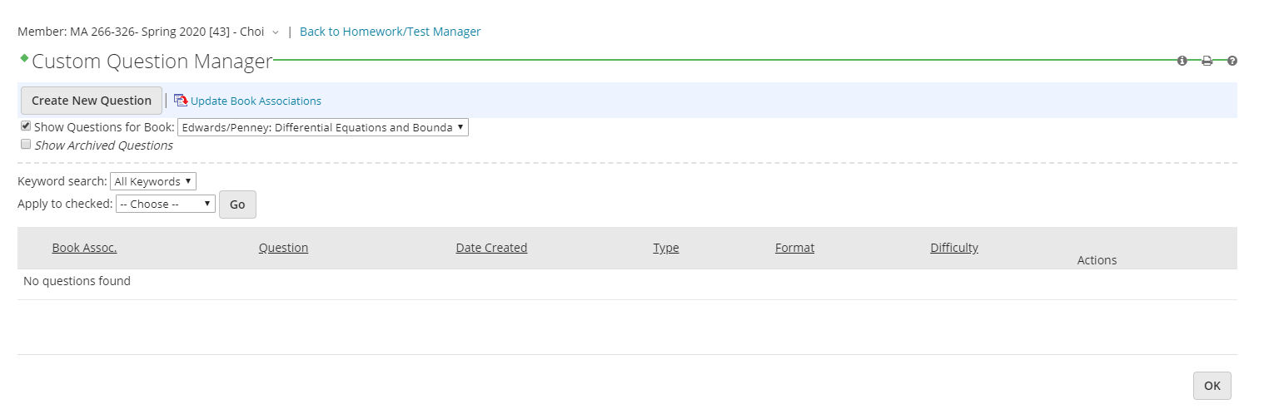
One of the main options for creating a custom question is to copy one of the homework problems and change randomizations. Here’s a sample.

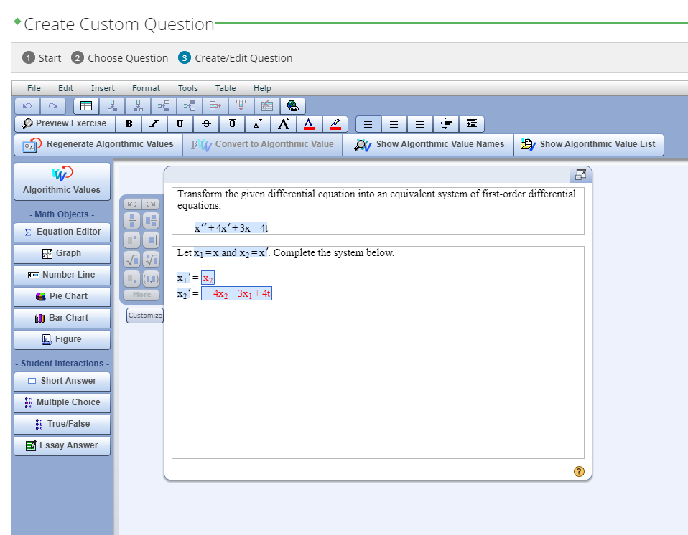

Numbers 4 and 3 in the questions are set as a parameter c1, c2 so the answer, seen on the bottom, are shown as a function of c1 and c2.

Individual approaches:

Xiangxiong Zhang: Zoom streaming/recording
Before spring break, I tried zoom for real time online lecture on Mar 11 Wed and Mar 13 Fri for both MA362 and MA615. It went quite well and well received by my students. Both students and I felt it as smooth as in the classroom. I have been using the following method since then.

- Expected outcome: interactive lecture+recording to share+saved drawings to share.
- Hardware: computer+iPad+apple pencil (or microsoft surface+surface pen).
- Software: zoom (pro account)+notability (a white board app on iPad).
- Setup: use computer to host a zoom meeting, use iPad as a participant; remember to mute the microphone on one of the two devices; share the screen of iPad and draw on notability in iPad; use computer as a monitor to check/verify what students can see through zoom; if any student asks questions, you can see who's asking on computer while drawing on iPad. No one needs to turn on any camera.
- For students: install zoom on smartphone or computer; send them your personal zoom meeting room address/ID (permanently associated to your account); ask students to use real name in zoom; ask students to mute their microphone, unmute it only when speaking; ask students to enter your personal meeting room just like entering the classroom.
- Streaming or recording: I did both for MA362. In zoom, record->record to zoom cloud. My MA362 class starts at 9:30am. Usually I click the recording button around 9:30am after verifying with students that audio is all good.
- What to do after class: click "end recording", zoom will email you a link to share the video. Check out my Mar 13 recording here. Jump to 14:35 of that video, you'll see a student corrected my mistakes:) Save notability drawing as PDF and share it along with the video link to students. Check out one of my saved notes here. Original notability file can also be shared with students.
- Class size: Zoom Pro account can hold meetings with 300 participants. I had 31 attendants for MA362 and 20 for MA615 on Wed. So zoom should be alright for small classes.
- A. Remark I: I used white board in zoom on Wed, which is also fine. Students prefer notability, which is indeed better.
B. Remark II: potential risk for real time lecture is due to unstable internet at least for some students. Recording is a failsafe.
C. Remark III: your zoom personal meeting room is like your virtual office/classroom and it can hold 300 students. You can personalize your meeting room, e.g., change ID number to your office phone number; change meetingID to your office number.
D. Remark IV: To draw on iPad, it is not necessary to have an apple pencil, without which however, smoothness will be reduced.
E. Remark V: So far I have encountered at least two technical incidents. One day my apple pencil suddenly stopped working during a lecture. After 1 minute of searching on google, I found it is due to loose tip: just screw it tight.
- My overall assessment: everything seems smooth if internet connection is stable. But that could be a big IF. Interaction in the physical classroom is largely preserved. Quite a few students told me in person that it's much better than they expected and they like real time zoom meeting + notability very much. For some aspects, it's even better than the physical classroom because I can switch to different colors and erase it very easily on my iPad, and all my drawings are saved as PDF. I can even mark on my typed up notes. I can switch between white board and typed up lecture notes very easily as well: show notes and whiteboard on iPad, just switch them, use computer to monitor the effect.

- Office hours: I have created courses on piazza.com which creates an online forum for the class and most questions have been answered there.
- Homework: use Blackboard. Course Content->Assessment->Assignment. Create an assignment and students will have a link after clicking that assignment to submit the picture/scan of their homework through Blackboard. Then Grades Center->Needs Grading->Click Student Name, you will see their submission and be able to mark/grade on it directly online.
- Exam: my friends in Hong Kong told me that they have monitored closed book exams for 100-200 students through zoom. Of course, a dry run is necessary for everyone to get familiar with technology. On April 6, I did a closed-book Midterm II for MA362 through zoom and blackboard. Overall it went well. Here is what I did:

- I ask students to put the camera by their side to show their faces, desks and computer/laptop screens at the same time. If they only have a laptop camera which is hard to do so, then I ask them to use a cell phone camera. By grid show, I can see 16 faces at one time. I had 34 students so I need to switch 3 pages to see all of them.
- All students need to turn on the camera and microphone during all time. There was one student with a noisy neighborhood thus I granted permission to mute microphone. One student had technical failure to join audio in zoom on his phone thus I had to communicate with him through chat (by typing) in zoom in the beginning, and later on he used a computer for zoom.
- I use blackboard for releasing and uploading exams. My scheduled in-class exam time is 9:30-10:20am. Set it up as an assignment under course content with available time as 9:29am. Students join zoom before 9:25am to test equipment, then everyone will see the exam after 9:29am and can start at 9:30am. I ask students to stop at 10:20am to scan their writings or take pictures by Office Lens, then upload back to Blackboard.
- I asked students to remain in the zoom meeting and keep the camera on after 10:20am until I can confirm their submissions. If students use a phone camera for both joining zoom and taking pictures of writings, then they will not show faces while taking pictures. I gave them a 2-minute window until 10:22am to go without showing their faces and desks. Most students finished uploading within 5 minutes but it took me more than 10 minutes to confirm with them one by one that their submissions were acceptable.

Jarek Wlodarczyk: Essentials for remote teaching
There are the following elements which I find useful for remote teaching and research.

1. Virtual office- Zoom or Webex. I tried both. Similarly as Xiangxiong I like zoom much more. It has features which I find useful and is very easy to use. I am going to use it for meetings with students, during office hours, proctoring exams, recording classes. (see Xiangxion’s comment)
I already recorded the first lecture and it was a very smooth process and a very satisfactory result. Zoom or Webex offices have permanent addresses of their personal rooms.
To enter your personal Zoom office one needs a fixed meeting id (room number) and a password.
Warning: If you do not use your personal room (in Zoom) and just start the meeting it may take you to a different room with a generated number.

2. Virtual whiteboard. When I meet with students in the virtual office and want to discuss their paper work or hwk or to run my classes, and finally to collaborate and discuss changes in particular papers I need a whiteboard.

For recording lectures and ad hoc conversations with students I use a whiteboard in my zoom office, which is pretty good. Note that, when permitted, a student can also annotate this board. For any other applications the annotation is just on the shared screen not on the file. (Webex whiteboard has only a marker for marking pdf files which is useless for me).
A big advantage of recording lectures on a zoom integrated whiteboard is that it produces very tiny mp4 files around 0.8MB/min (65 MB/ 1hr 15min lecture)

To discuss scans of the student work I use:
Aww web whiteboard: https://awwapp.com/
I embed students' pdf or jpg file inside a board and write on it. The student can also write on it at the same time if you send him a link.

For collaboration it looks like ziteboard is the best: https://ziteboard.com/ In this case you and your collaborators always see the same part of the board. In aww you see the same board but maybe different pieces of the same file. Ziteboard has also voice support so you don’t even need your office to talk to you peer. (Pro account is 10 USD a month)

3. Virtual pencil. In order to write on a whiteboard I use a cheap graphic tablet with a pen for 30-70 USD. (It took me a few hrs to learn it). It gives a pretty good precision. (I tried three of them and use Wacom Intuos now (70USD). This one is pretty small but good enough for me)
If you like the feeling of writing on the paper you can place a paper on top of the tablet, taped underneath or make a paper sleeve. It really works.
Of course one can use an iPad or tablet.

4. Online access point- Announcement board- I use Microsoft one drive- I post my lectures or all the files I want. Students can also edit, ask and answer questions and etc. (This is like Piazza)

5. For grading, submitting hwks and exams I use Gradescope. It greatly facilitates grading exams and hwks. It is very easy to set up your classes and hwk assignment. You just need cvs files with student rosters downloaded from my Purdue and it takes a few moments. It is also very easy to set up the exams.

The Exam is just a hwk with a short: like 2hrs, time window between the release of the exam and submitting the solutions by students (plus 10 minutes for uploading). It can be an open book format or as Xiangxiong mentions, closed book proctored in Webex or zoom. Here is a link about proctoring online exams in zoom (with canvas) but the same works for zoom with gradescope:
https://bokcenter.harvard.edu/remote-exams

Warning: Do not set up the exam in Gradescope As Exam (The exam should be set up as hwk). The exam in Gradescope means the traditional format when the instructor collects the solutions, scans them, and submits the files. In this case the students should submit their exams as they do with hwks.

Arshak Petrosyan: Detailed notes on iPad recording

A side note to my writeup below. In principle, neither iPad, Apple Pencil, or extra software is necessary, if there is a scanner (or perhaps just a smartphone with a scanner app). That is, the notes can be written on paper, scanned into a PDF file and opened in the full-screen mode in a PDF viewer such as Acrobat Reader, while recording the entire screen and using the mouse as the pointer. Screen recording is readily available on recent versions of macOS, as described here

https://support.apple.com/en-us/HT208721

and there is probably something similar on Windows as well. One problem is that the file sizes could be very large. Starting macOS Mojave (10.14) one can also record a portion of the screen, so instead of opening the PDF file in full screen mode, one could fit it in a smaller window and record that, hopefully producing smaller files. However, I wasn't able to test it as I am still running macOS 10.12 and kind of scared to update now.

Here is an example video obtained by the method I described:

https://mediaspace.itap.purdue.edu/media/0_rbidukrm

-------------

Using iPad for online lectures

(1) Writing notes

I use Notability app, which is really great. There is also Goodnotes 5, which I hear could be better. In Notability one can also record audio while writing notes. In playback, it will even show the notes appearing as you speak, as if you were writing on a board. You can stop recording, go back and redo if necessary and it works really great. Here is a relevant video

https://support.gingerlabs.com/hc/en-us/articles/206060617-Recording-and-Playing-Audio

This is the closest thing to simulating a blackboard lecture that I could find. However, in reality, writing on iPad is noticeably harder and slower than on a blackboard. I guess when I get more proficient with writing on iPad, I will switch to this method, but for now I just write the notes without audio and then use the presentation mode in Notability with simulated laser pointer to record video for the lecture.

(2) Recording videos.

There are at least four ways to record videos your from iPad

(a) Screen recording directly on iPad. Convenient, but videos could be large. See here

https://support.apple.com/en-us/HT207935

(b) Connecting to a Mac and recording with QuickTime player (Record New Movie, choose iPad as the source for video and audio). Files are smaller than recording directly on iPad. This is the method suggested by Notability

https://support.gingerlabs.com/hc/en-us/article_attachments/205125438/EDU_Guide_1_-_Flip_Your_Classroom_Using_Notability.pdf

(c) Connecting to a third party app on a Mac: Reflector 3 (https://www.airsquirrels.com/reflector) works well (mostly), but costs some money (<$20). This allows to connect wirelessly by AirPlay and can be configured to produce videos of reasonable size (about 3mb per min) and reasonable quality (720p). Personally, I use this method, as it works well in Notability's new Presentation mode.

(d) Connecting to WebEx on the computer and sharing a device (iPad in this case). One can have a "single person meeting" and record the lecture that way. Recorded video goes automatically to Kaltura Mediaspace, like Boilercast, which is really great. All seems fine, but there is two issues:
- in the recorded video the shared device does not fill the entire screen. Since WebEx is really for videoconferencing, it also records small thumbnails of participants, which in this case may not be optimal. While this should be configurable per Cisco's documentation, Purdue's custom interface does not allow it and changing it now is a bad idea (I have been in contact with both Cisco and ITAP about this).
- sometimes it does not record the device at all, just an empty screen. I guess "focus" shifts somehow to something else and this can be classified as "user error", but I couldn't find a reliable way to tell if the device is being really recorded.

(3) Sharing videos.

Kaltura Mediaspace https://mediaspace.itap.purdue.edu is the "standard" place and if you use Blackboard that's the best way to share. However, one has to take into account that after uploading the video, it may take an extended time to "transcode" it, before it appears online, especially in high resolution. Per Kaltura, for 360p videos the transcoding is nearly instantaneous, but for 720p videos it can take 4-8x the length of the video, and for 1080p videos, it can take 10-15x times the length (see here https://knowledge.kaltura.com/help/kaltura-media-transcoding-services-and-technology). This means one has to record videos well in advance for higher resolution videos.

