Connecting Your Gradescope Course to Brightspace

Description
Gradescope is an online grading tool for scanned, pen-and-paper, free-response assessments. This tool supports workflows for both individual student assignment (homework) and instructor upload of assessments (exams).

Creating A Gradescope Module
This step is optional, but by creating a module in Brightspace for Gradescope you provide students with an easy place to find their Gradescope link and any associated support documents or instuctions.
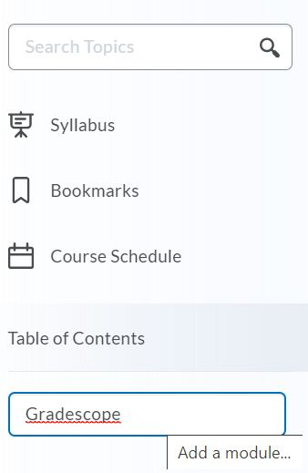
- Login to Brightspace at https://purdue.brightspace.com and enter your course.
- From the bottom of the left sidebar, click on the module creator tool.
- Type Gradescope and press enter to create a new module. This will open the module when it’s created.

Adding A Gradescope Link To Your Course

- Inside your new module, Click on “Existing Activities” and select “External Learning Tools” from the drop-down menu.
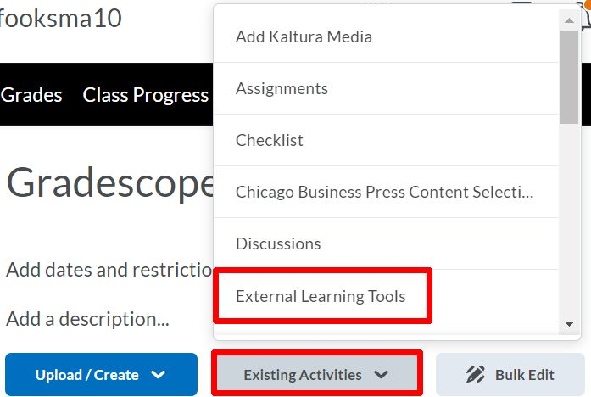

- When the Add Activity page opens, either scroll down or enter “Gradescope” in the search box.
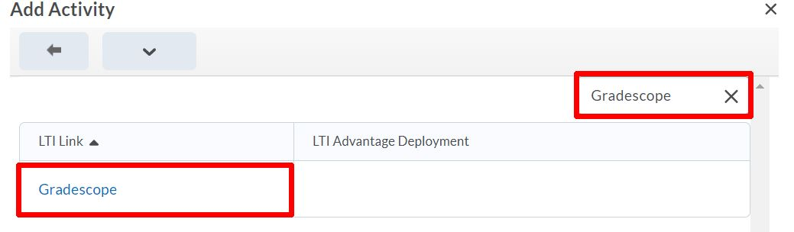

- Click on the “Gradescope” LTI. This will add a direct link to Gradescope to your Gradescope module.

Creating and Connecting Your Gradescope Course

- Click on the new Gradescope link that you just created. This will open Gradescope inside your course. (To open as an external resource, skip down to the last section in this guide.)
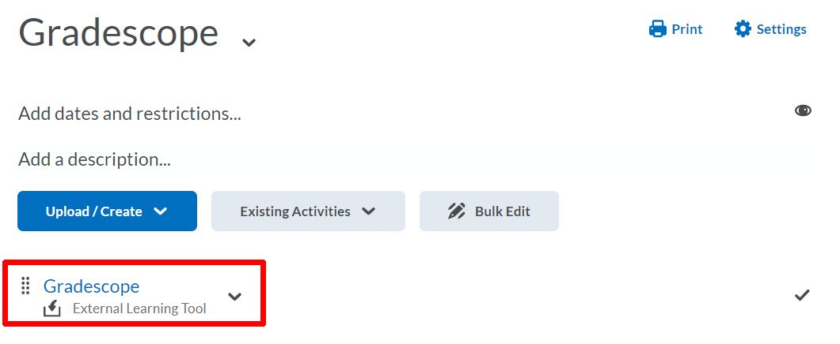
- If you need to create your course in Gradescope, click the radio button next to “A New Gradescope Course.” If you’ve already created your course, click the radio button next to “An Existing Gradescope course” and select the correct course from the drop-down menu.
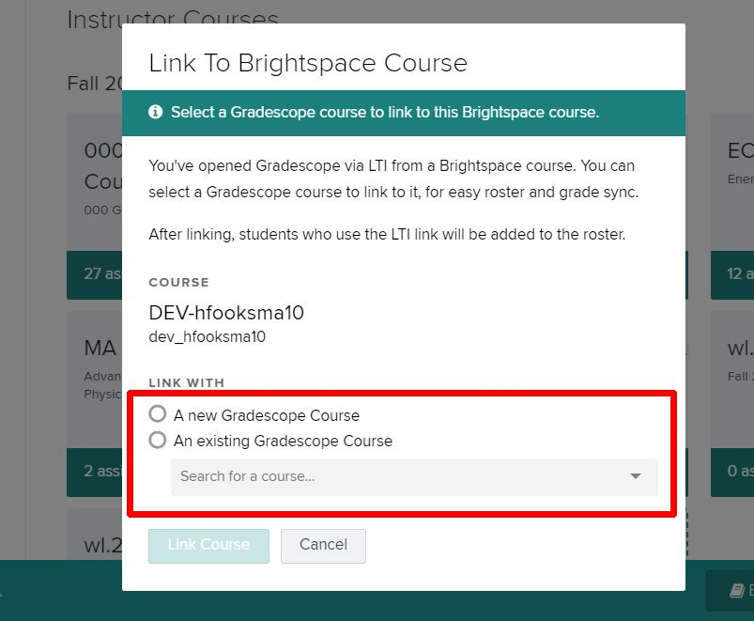

Updating Your Course Settings
- Gradescope will automatically populate your course name and number from Brightspace. You can change these to display as you choose.
- Ensure that your course is in the correct term by clicking on the “Term” drop-down. Until September 1st Gradescope will default to Summer. Until January 1st Gradescope will default to Fall.
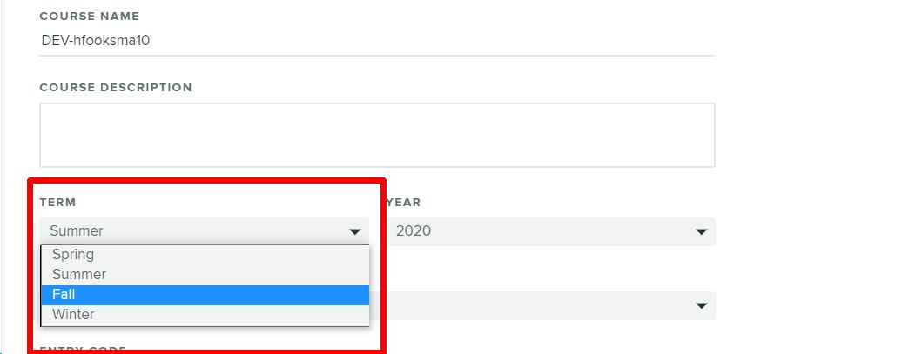
- Scroll to the bottom of the page.
- Click “Update Course” to save these settings.

Congratulations, your course is now ready to use with Gradescope.

Opening Your Course as An External Resource

- Click the drop-down menu next to the Gradescope link.
- 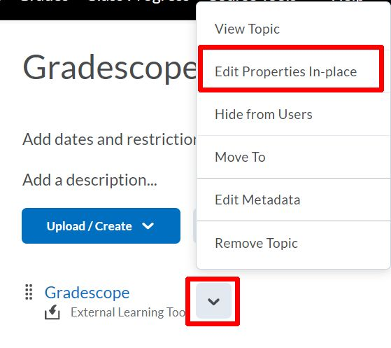
- Click “Edit Properties In-Place.”
- Click the box next to “Open As External Resource.”

- Refresh the page to finalize the change.

Additional Support

For additional assistance with getting started with Gradescope please email tlt@purdue.edu for support or visit the ITaP Training Calendar.
Gradescope provides a robust assortment of instructional videos inside the get started guide for new users of the tool.

